Dependency inversion principle – High level module should not depend on low level module . both should depends on abstraction.
let see what will happen if the high level module depends on low module
here notification service – high level class
email and sms are low level class
Tightly coupled – eppa email service od method name ha change panna enga vanthu change pananum
flexible -if I want to implement whats app notification service I should add the refence and then add it in constructor we have to change the high level class
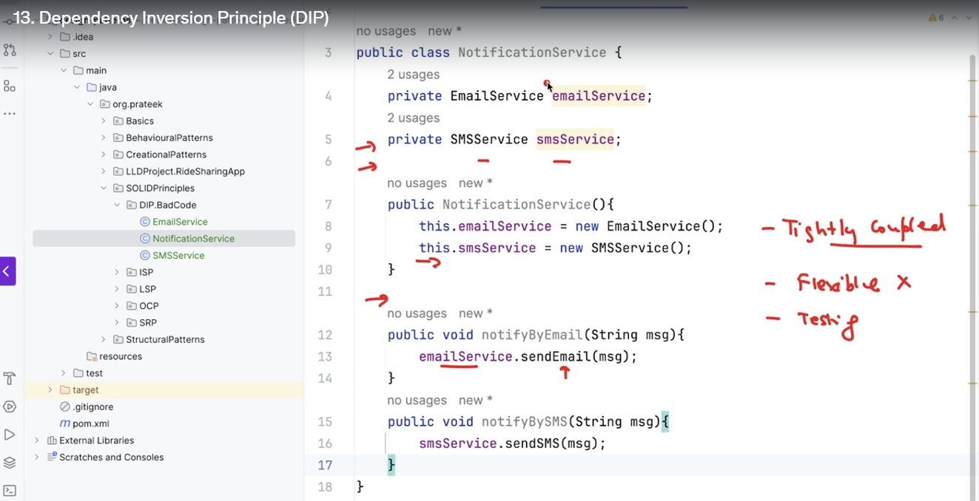

fix
now your notificationservice depends on notifaction channel it is interface or abstract class
the email and sms service impemenst notification channel interface . if we add whatapp notification service we just implement the interface here no need to change notificationservice 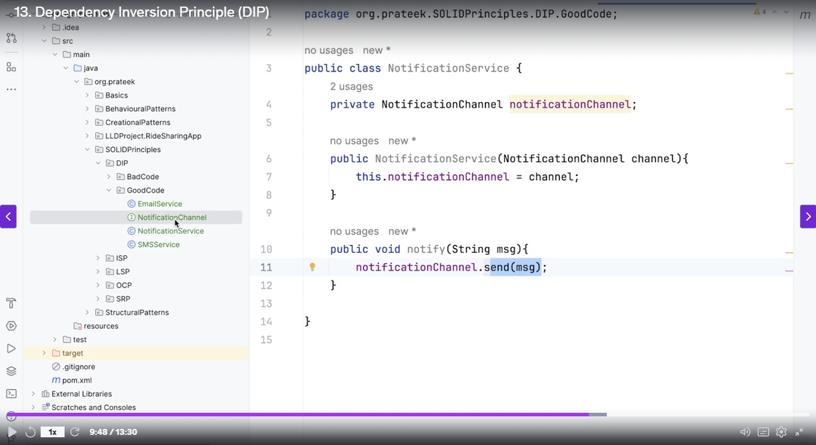
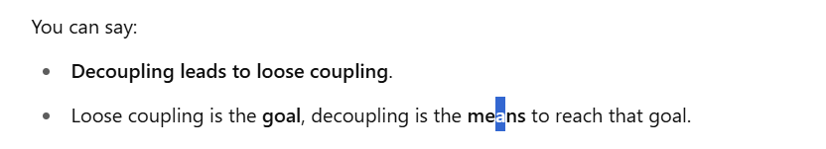
🔹 Loose Coupling
- Definition: Components or classes are minimally dependent on each other.
- They still interact, but changes in one component have less impact on others.
- Promotes flexibility and easier maintenance.
🔹 Decoupling
- Definition: The process or action of reducing or removing dependencies between components.
- Goal: To move towards loose coupling.
- It's a design goal or strategy.
Liskov substitution principle – parent class two methods eruku nu vachuka . subclass atha extend panuthunu vachuka adhula eruka oru method ku adhu expection throw panura mathiri eluthirukan nu vachuka adhu thapu . main class la antha method call pana error return panum
lsv principle complete ha parents method accept pannaum eppa na child la new method kuda create panikalam and parent method ha vennanu sola kudathu .
this we cant
class Bird {
void fly() {
System.out.println("Bird flies");
}
}

class Ostrich extends Bird {
@Override
void fly() {
throw new UnsupportedOperationException("Ostriches can't fly!");
}
}
This we can do
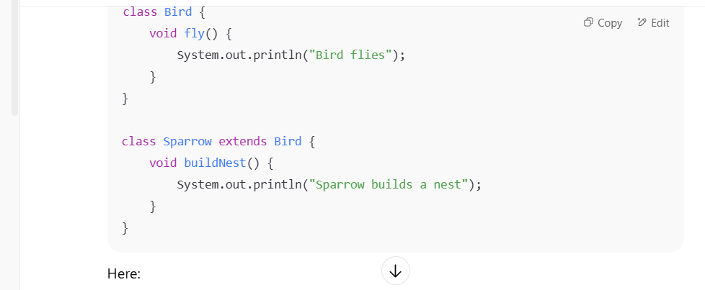
Design pattern
three types of pattern
Creational pattern – focus on object creation problem.
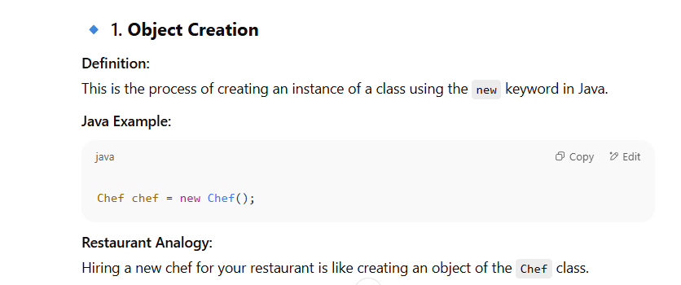
Structural pattern – focus object composition problem.
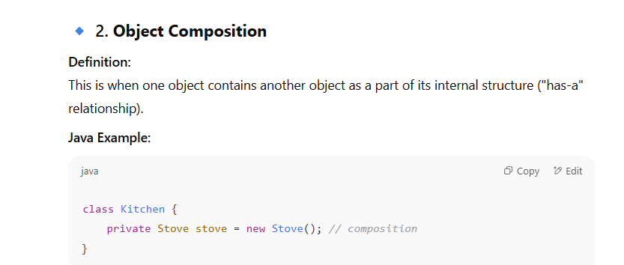
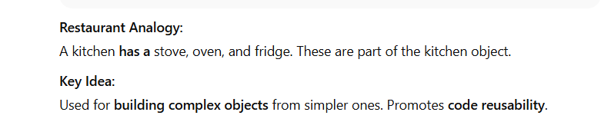
behavioural pattern – focus object communication problem.
object communication happens in many way . but mostly it happens via method class
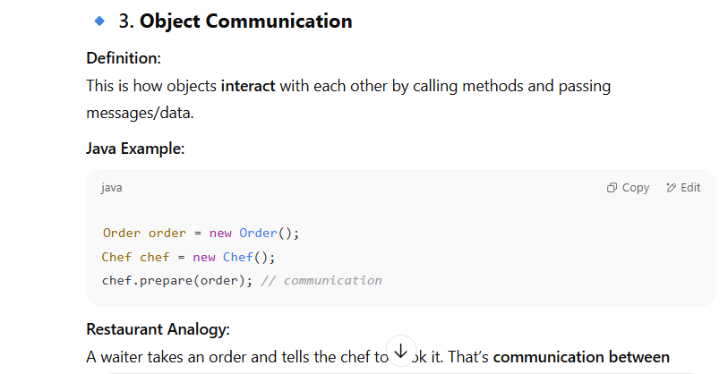

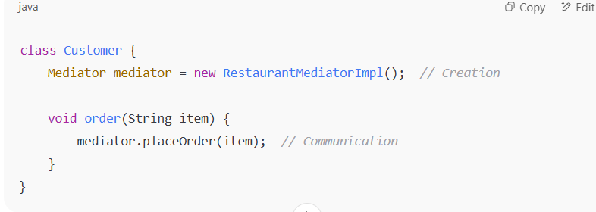
• Creating mediator is not communication.
• Calling mediator.placeOrder(...) is communication

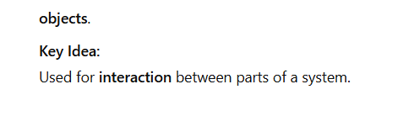
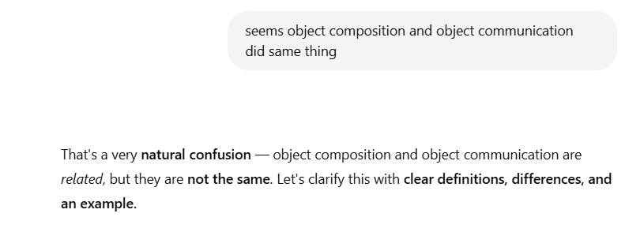

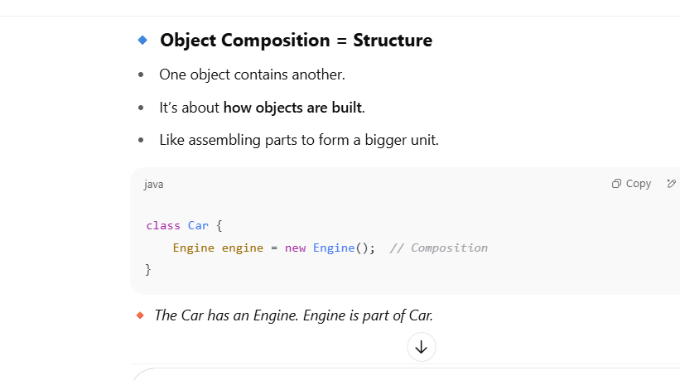
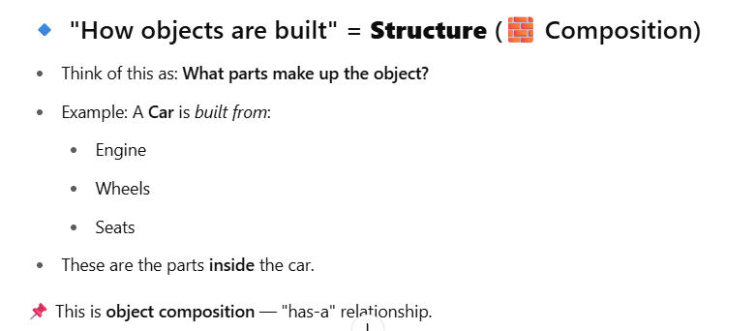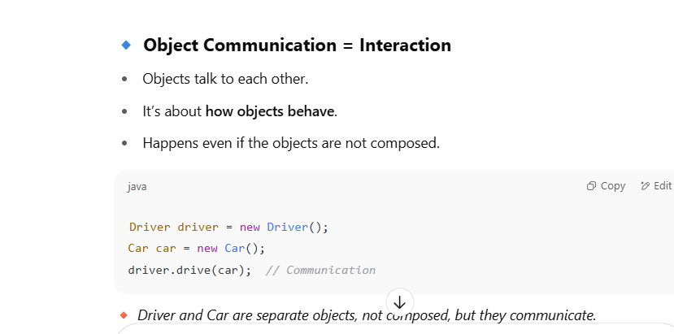

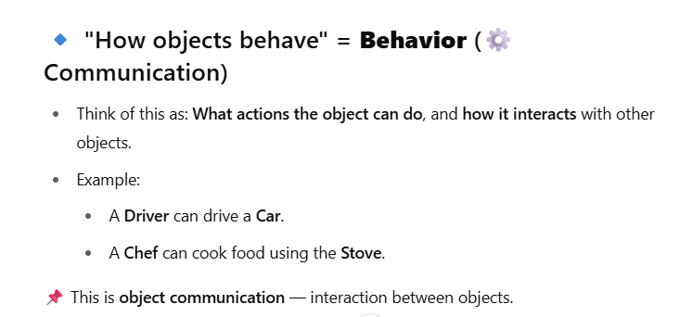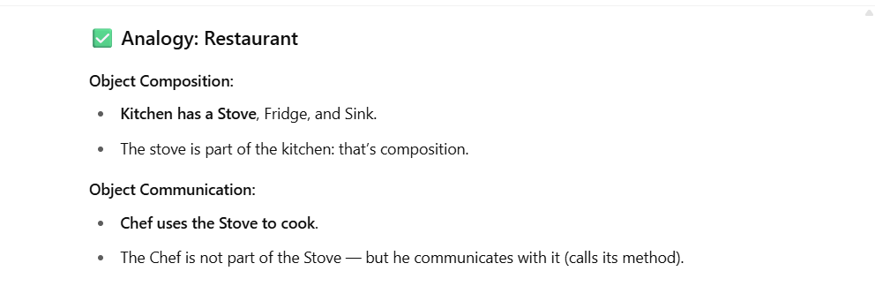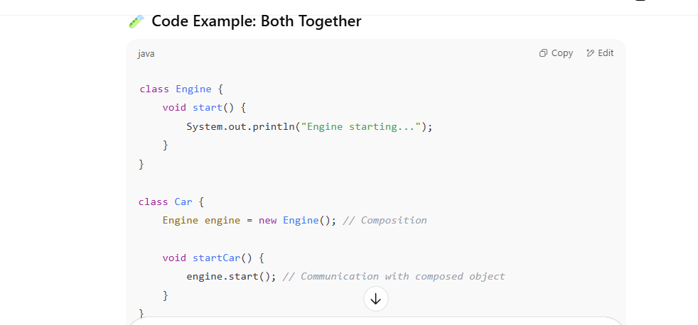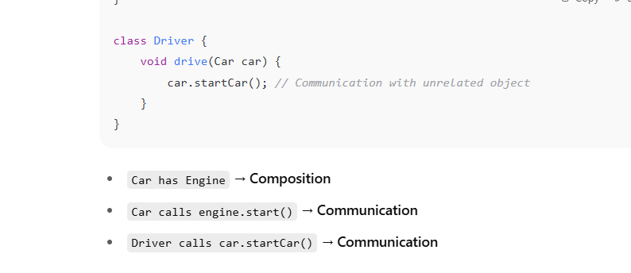

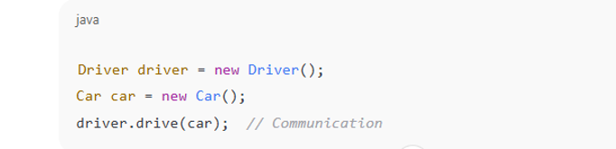

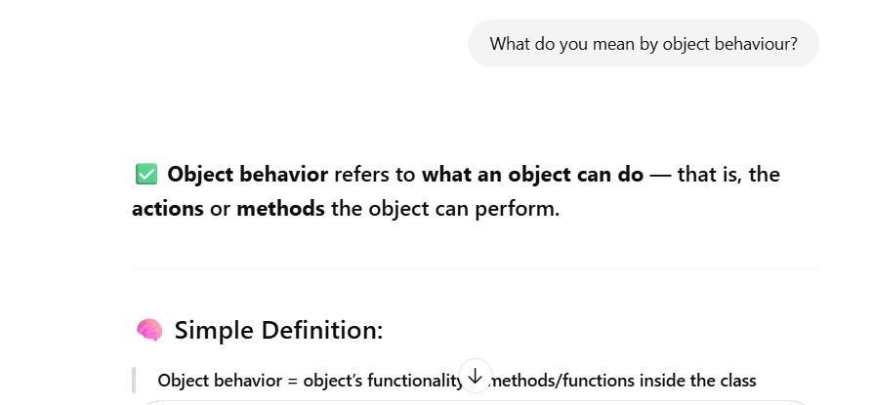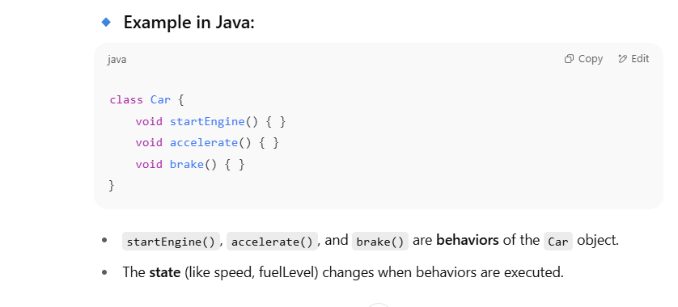
The state (like speed, fuelLevel) changes when behaviors are executed. Give me a simple example
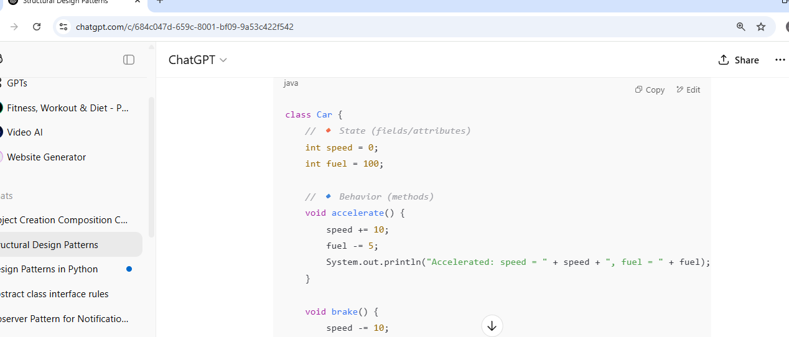
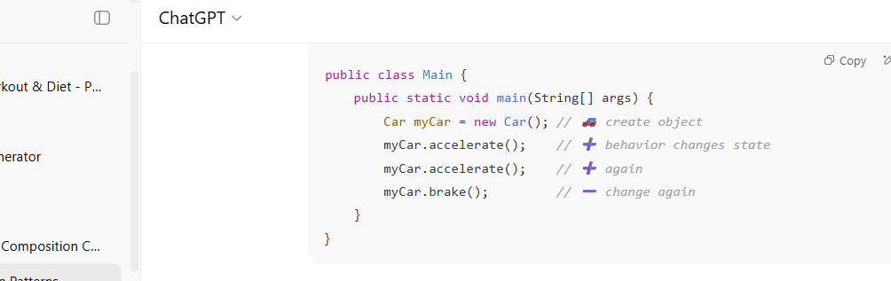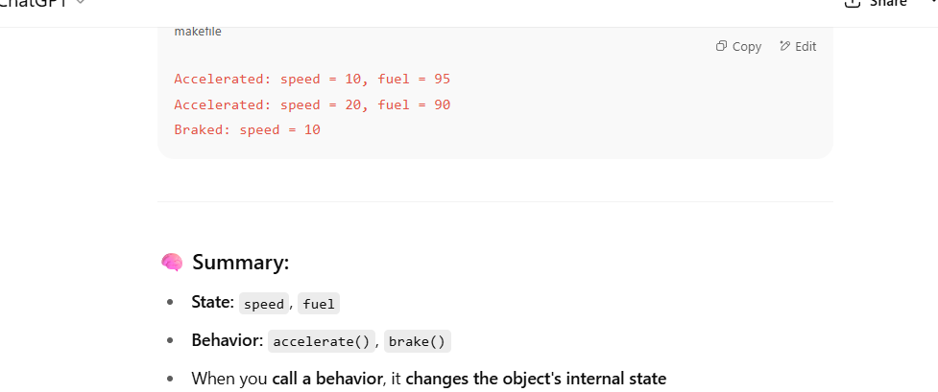
Clean,Scalability, flexibility, Maintainability of the code
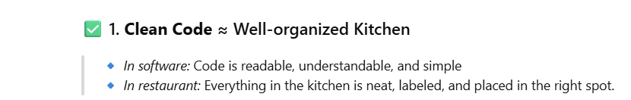
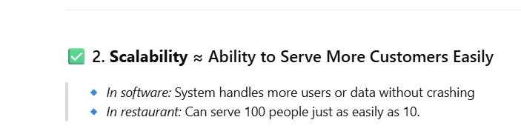
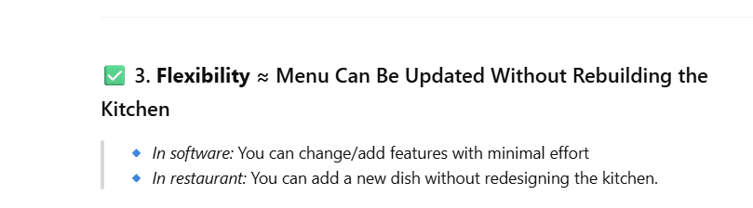
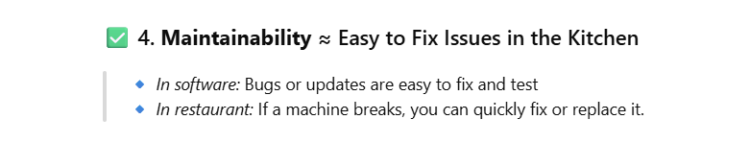
✅ "Error-prone" means likely to cause errors or bugs — either during development or while the software is running.
Difference between final in literal variables And variables using new keyword
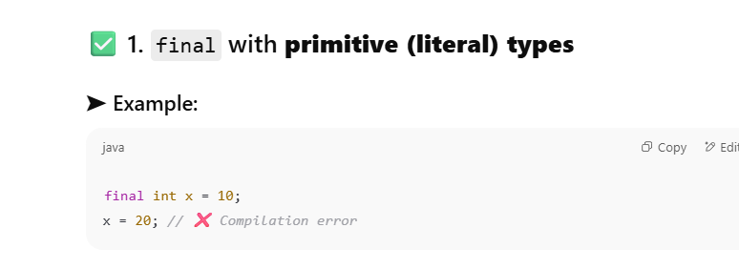
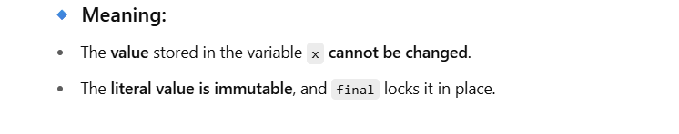
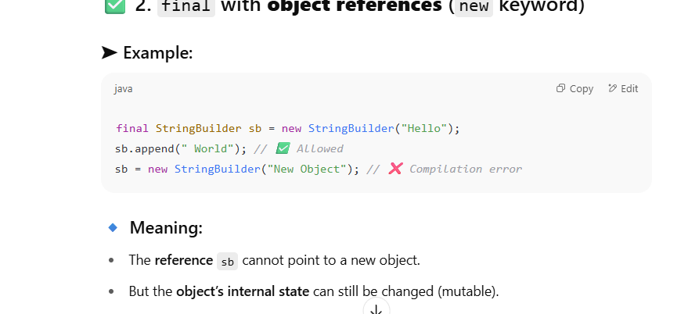
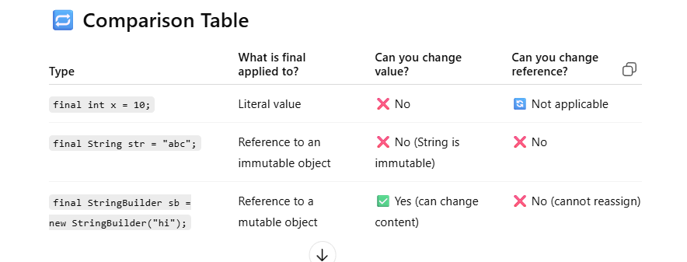
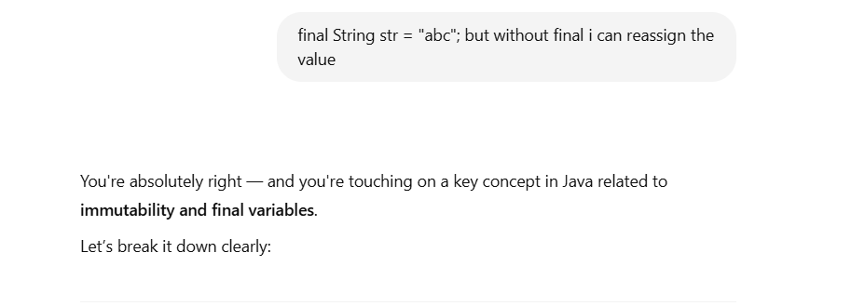

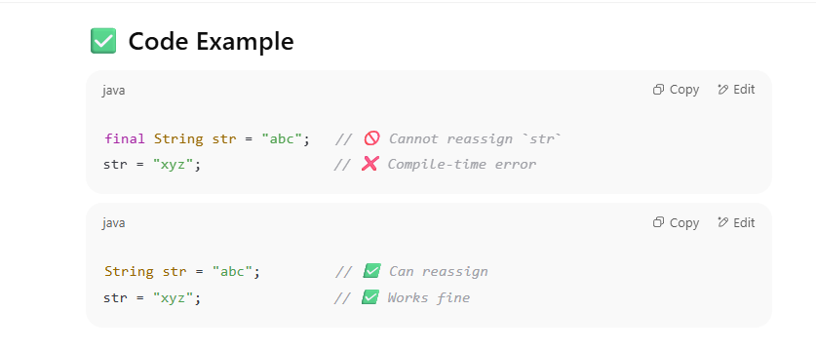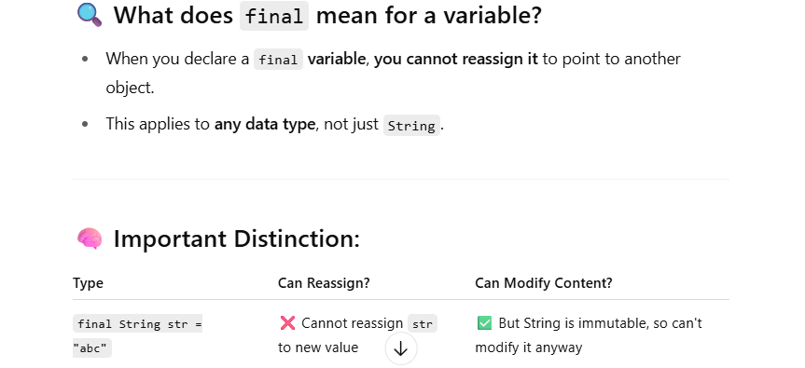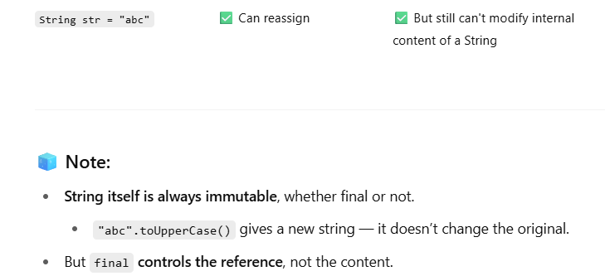

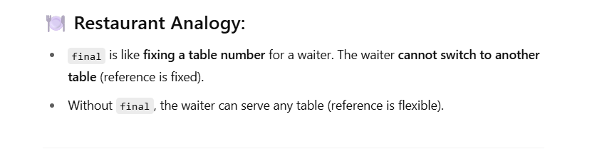
Start with pattern
Behavioural pattern helps in object communication and loose coupling
State Transition
State = The current situation of an object
State Transition = A change from one situation to another, caused by some event or action
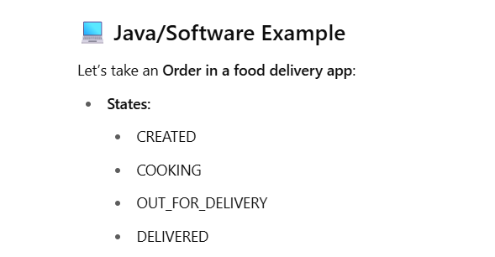

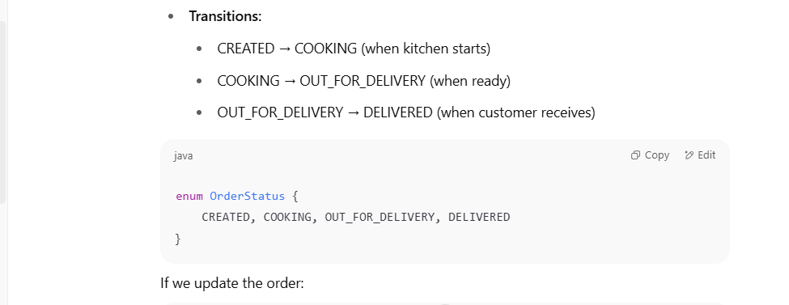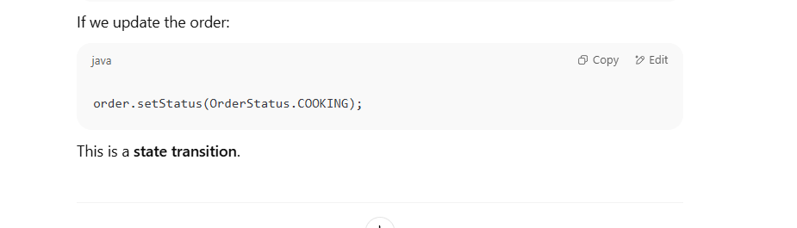

Overall view
simple create panuven , structure pani connect panuven , connect panatha communicate pana use panuven.
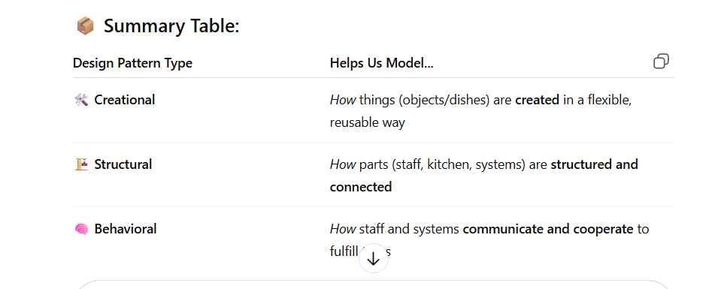
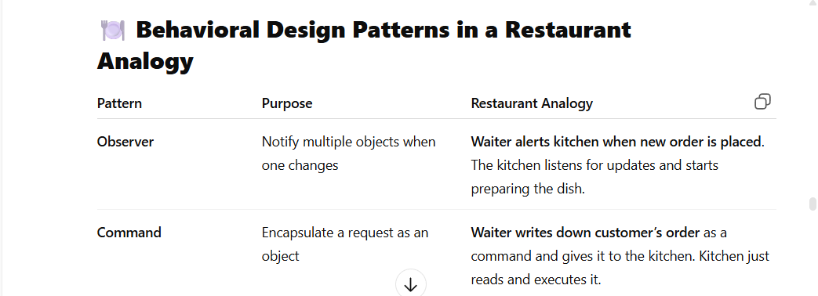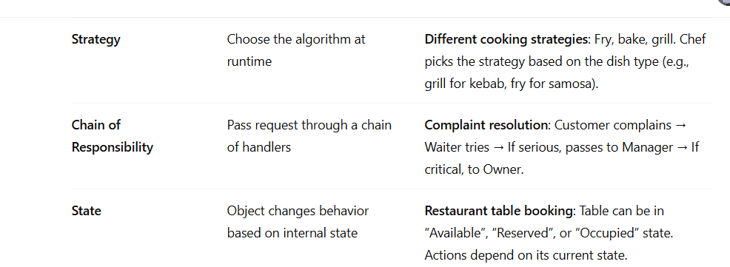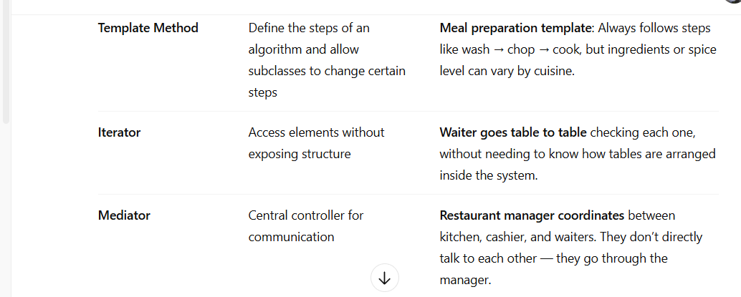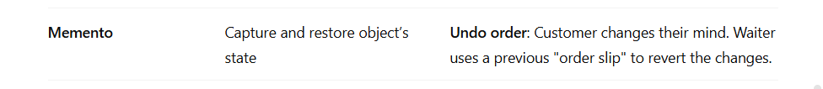
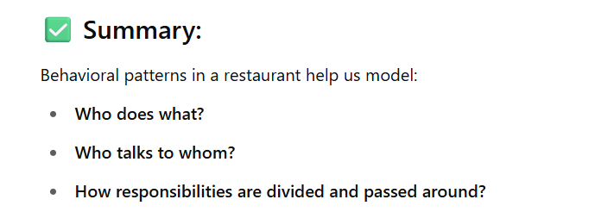
Momento Pattern
In momento pattern I just want to store the previous state of the object. Dealing with state
check the code
Conclusion – state ha oru object la potu antha object ha stack kula poturuuvan.
Observer Pattern-based on state changes
read below and check the code
it establishes one to many relationship
Allowing multiple observers to be notified when a subject state changes .
It is useful for event -driven system
is there any change in the subject state . we have to notify to our observers .

Iterator pattern
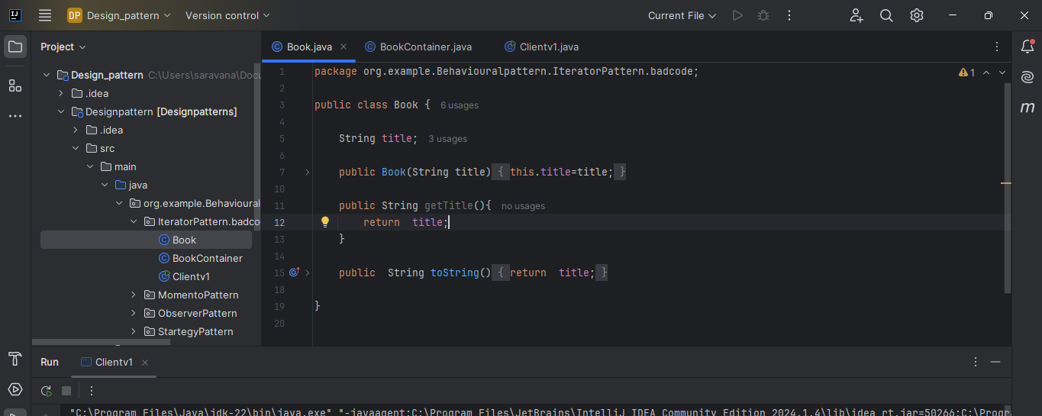

Consider I am running a library
so I use Array list to store the books
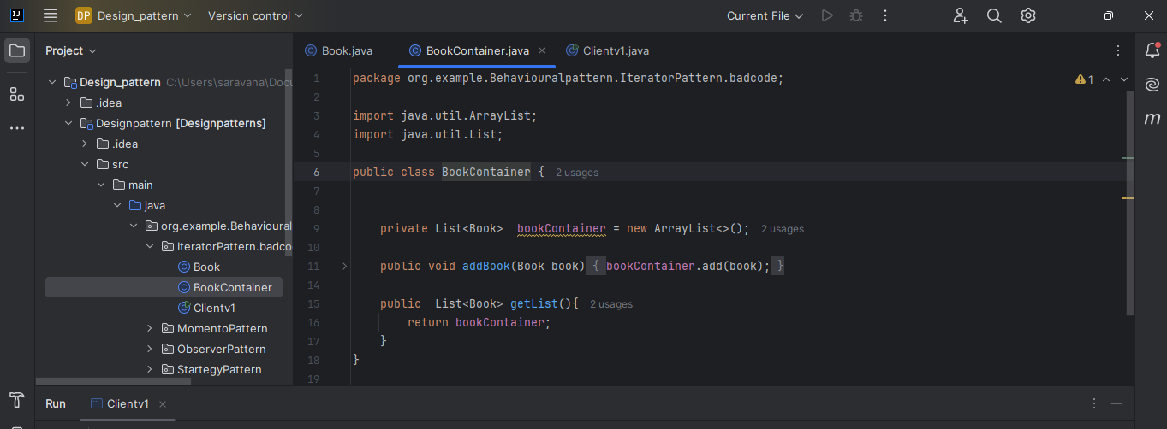
Client can access the books through for loop
problem – but if I change the storage mechanism to Treeset . I have to change the for loop that is client code . things to note any changes done we have to change internally .we don’t ask client to change the code

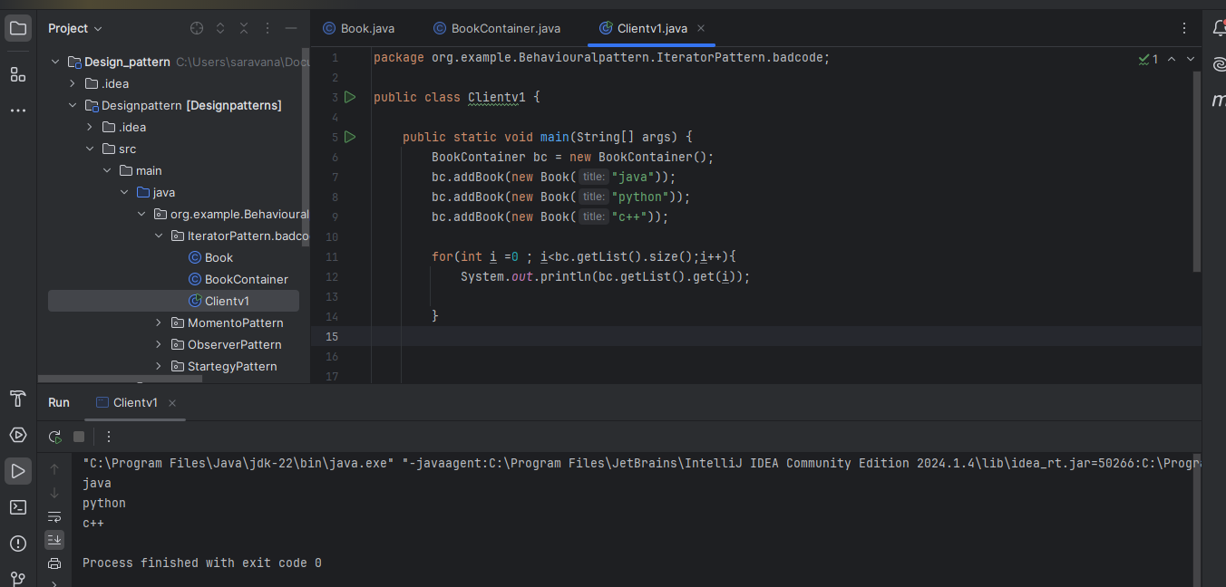

To avoid this problem use interface.
Ehdula than innerclass concepts la varum . edhodathulam office laptop la newlearnings oru folder la vachurukan
Here I implemented list . if you wants to implements treeset you should implemenst addition comparable interface in book class because trees set give ascending order so we need to sort first. No need to change anything client side now
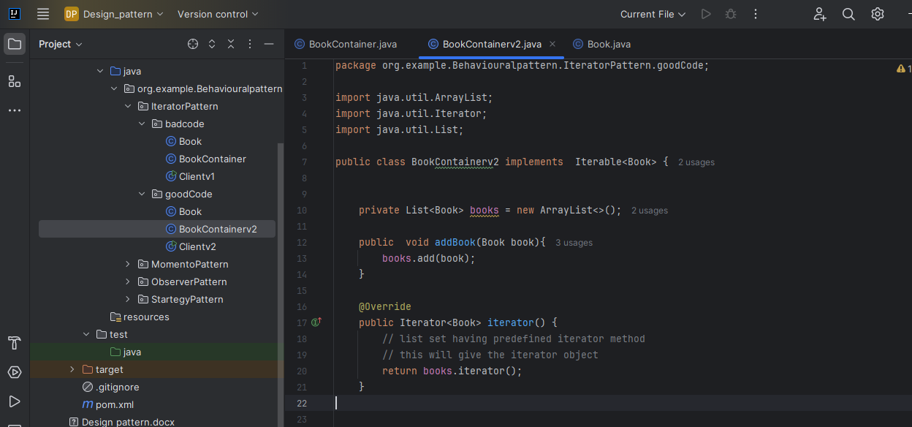

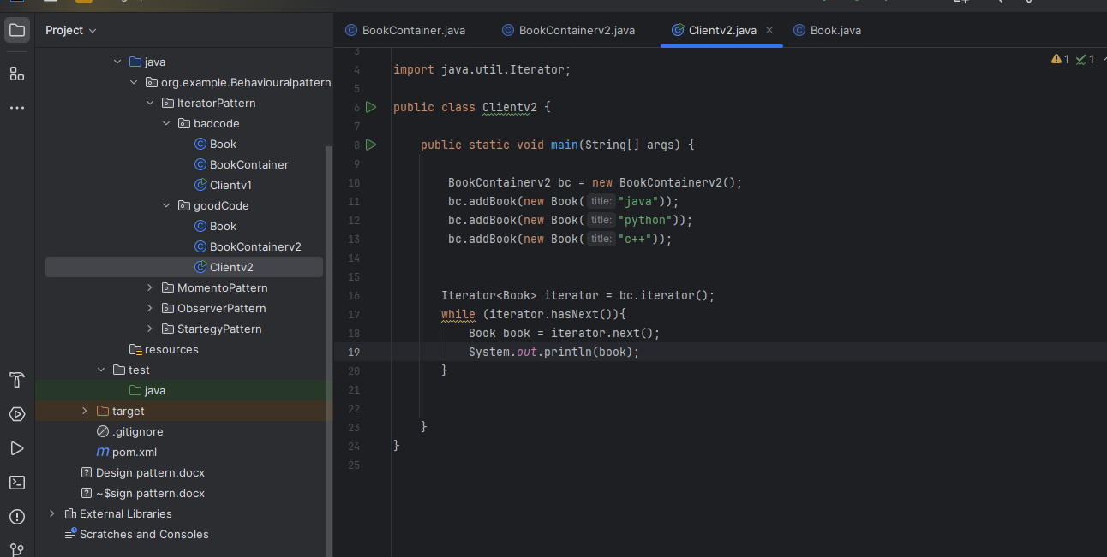

Template method pattern

Badcode
You can see openfile method and close file method are same repeated multiple time
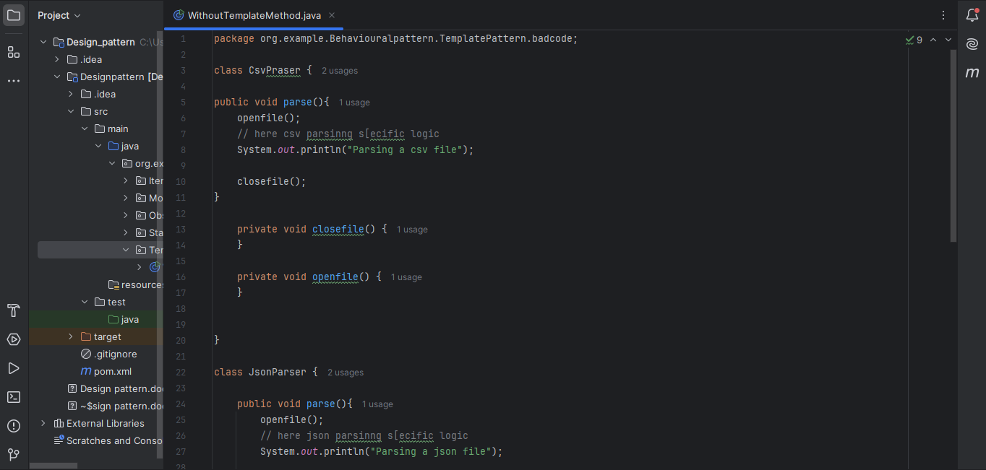

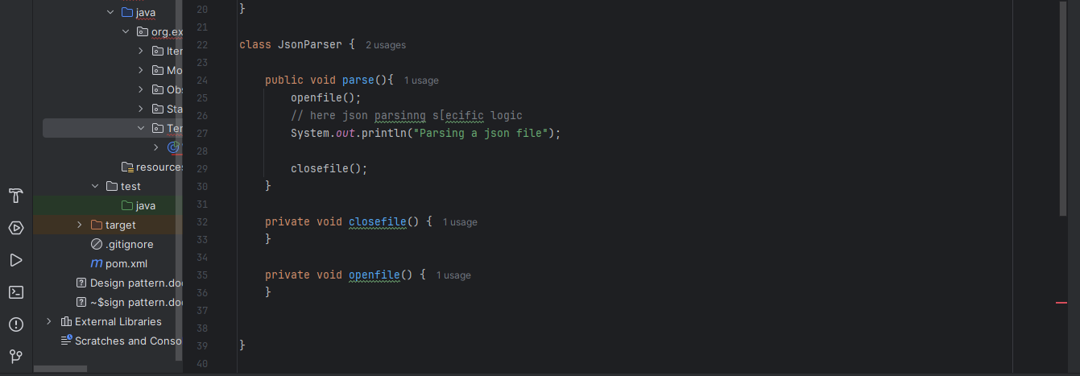
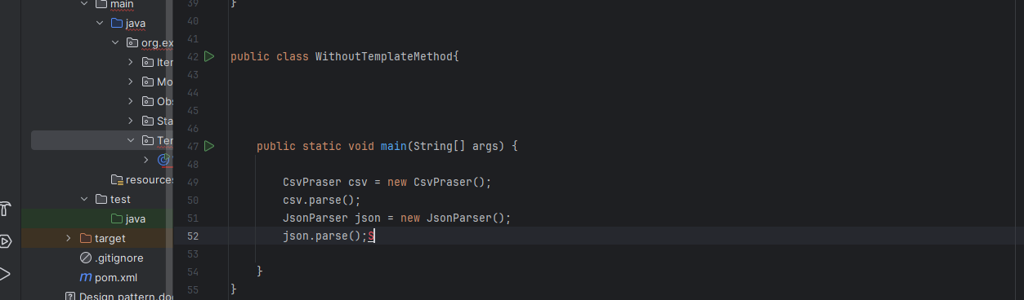

Goodcode
Create one abstract class put common code in default method make specific method as abstract method .

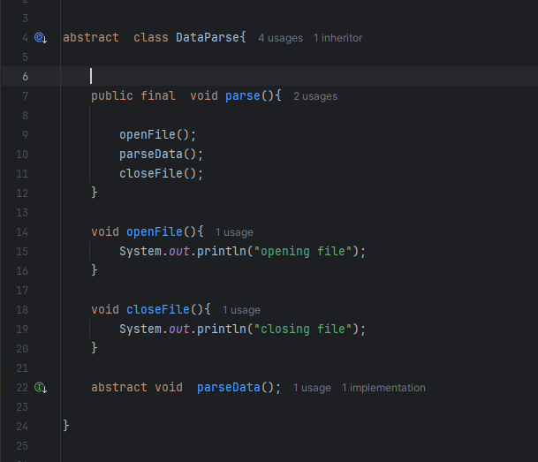

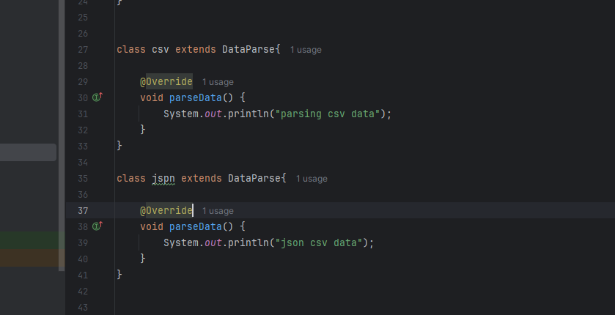

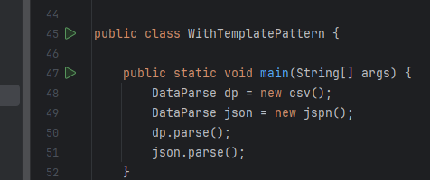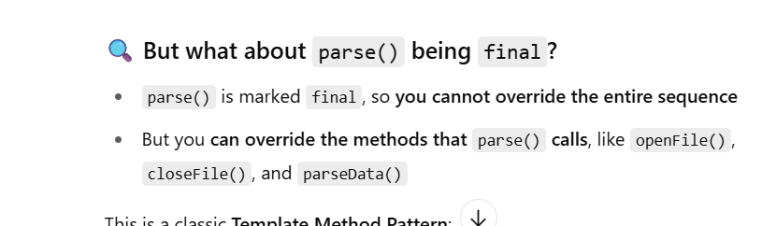

Creational pattern
Focuses on objection creation.
Client will not create object abstraction layer will create the code.
it hides the object creations.

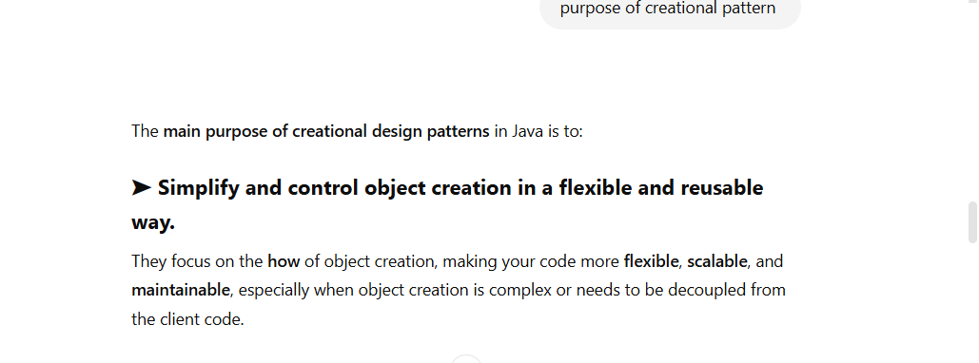

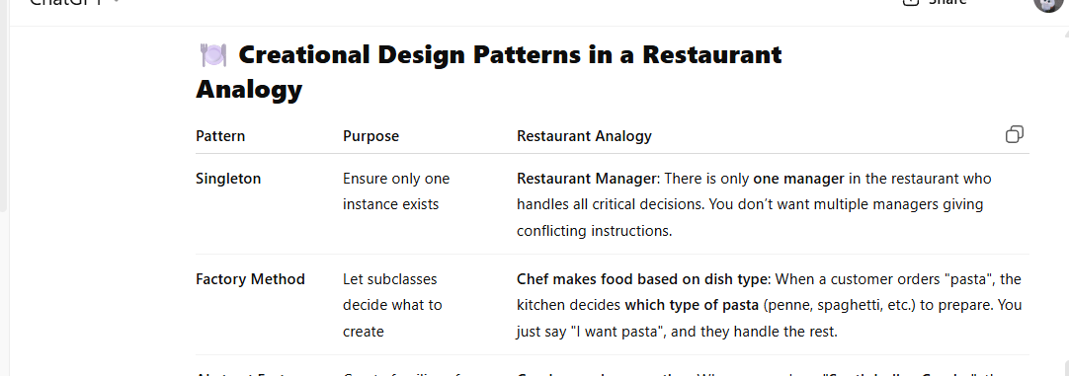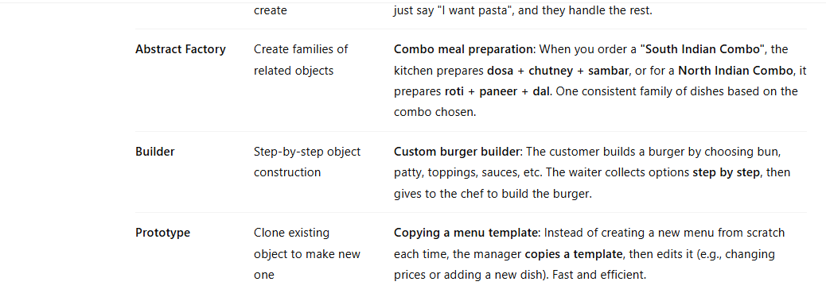

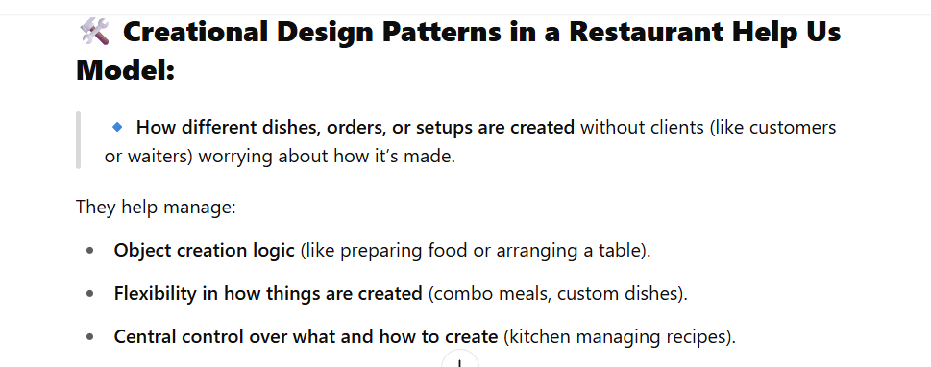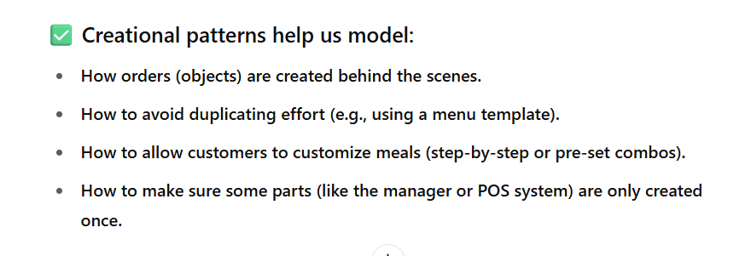
Singleton design pattern

There is an scenario to create one object for one class.
Eg db connections, logger file.
You ha app config class you set api key as 1 and created object for that next you create 2nd object and set apikey as 2. For this kind of scenario we need to create only one class
another example related to memory . for eg the object created at 100mb if you create 5 object it will take 500mb

Final solution
if someone wants to create a object we don’t want them to allowed we should give the objects already we created let see the scenario
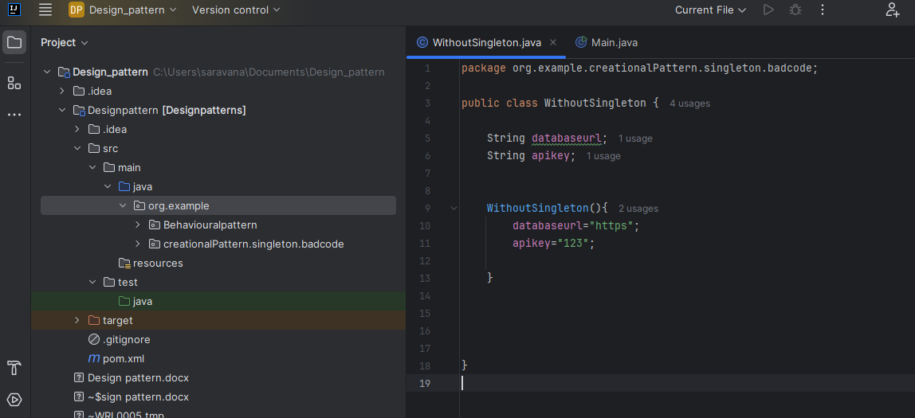

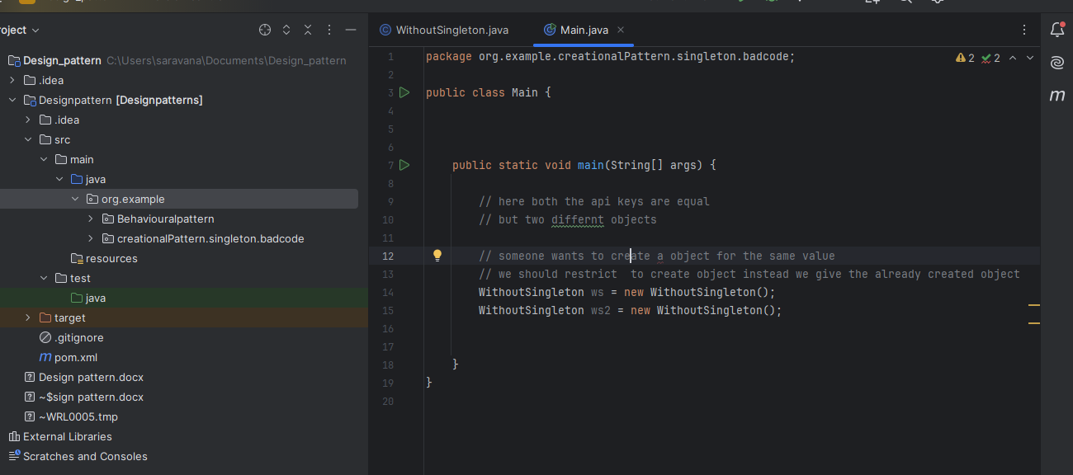

withSingleton
3 steps we should follow
step1:
instance variable should be private static
why private – no one can see
static – we create a instance inside the static method
step2: create private constructor no one can create object even you also
Step3: create static method to create a instance of the class

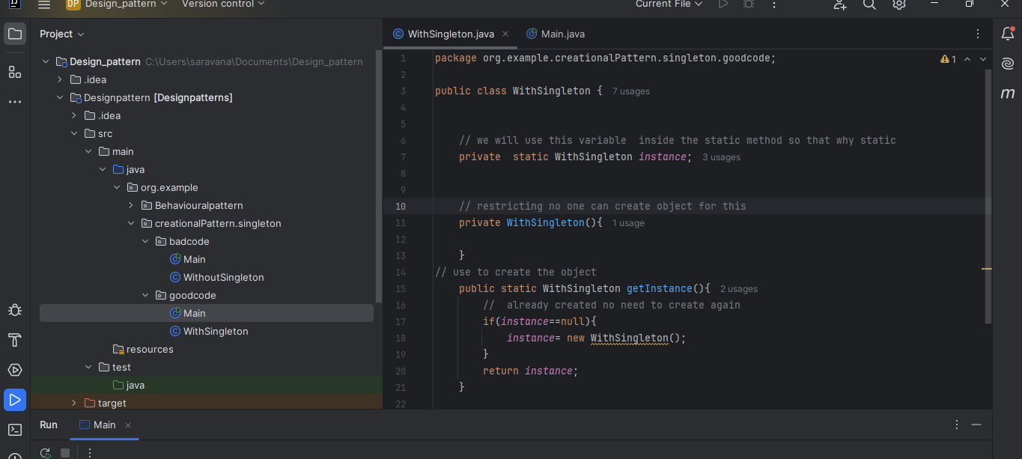
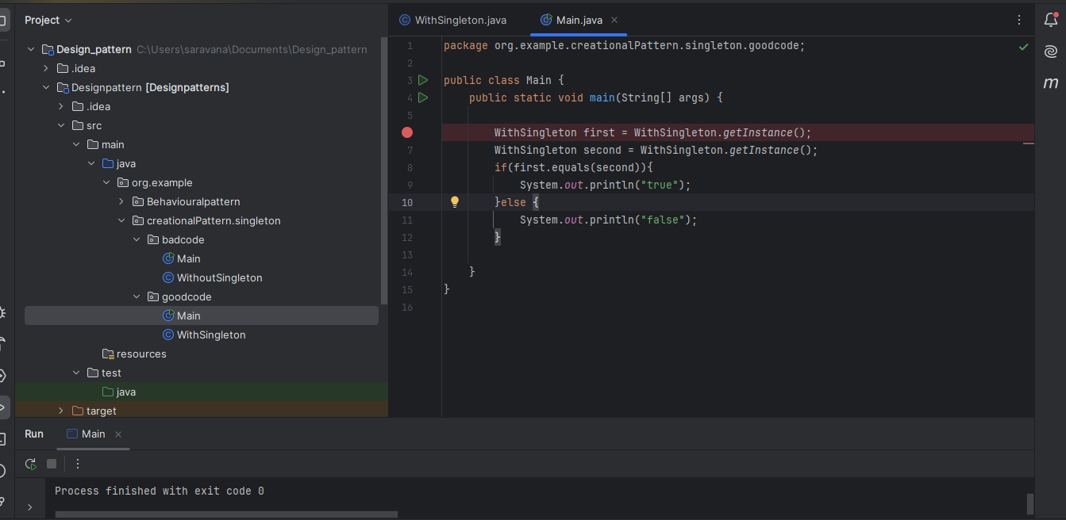

Factory pattern

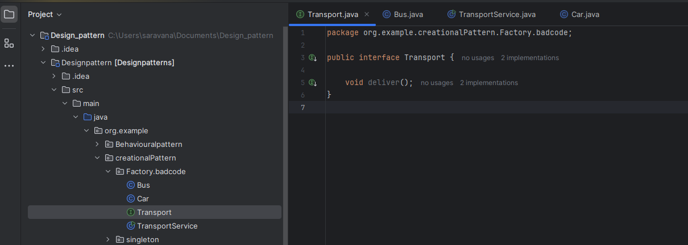
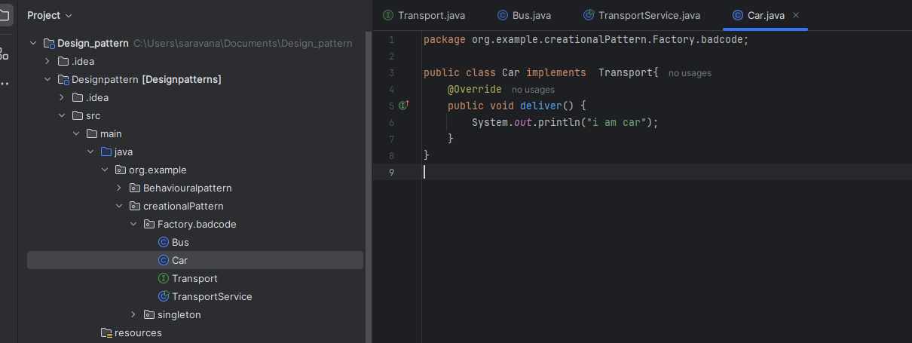

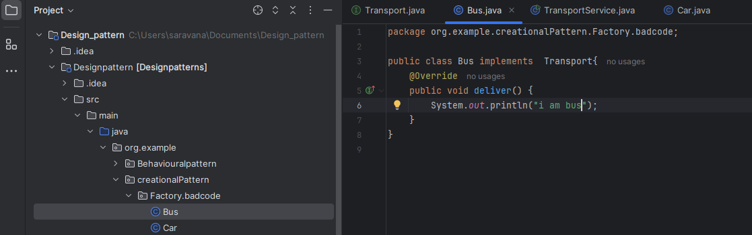

Naliku bike venum na transport interface ha extend panitu enga vanthu object create panuven
main na ena na client object create pana kudathu . client call matum than pananum
object create panurathukuna thani oru class eruku adhu than create panum object ha.
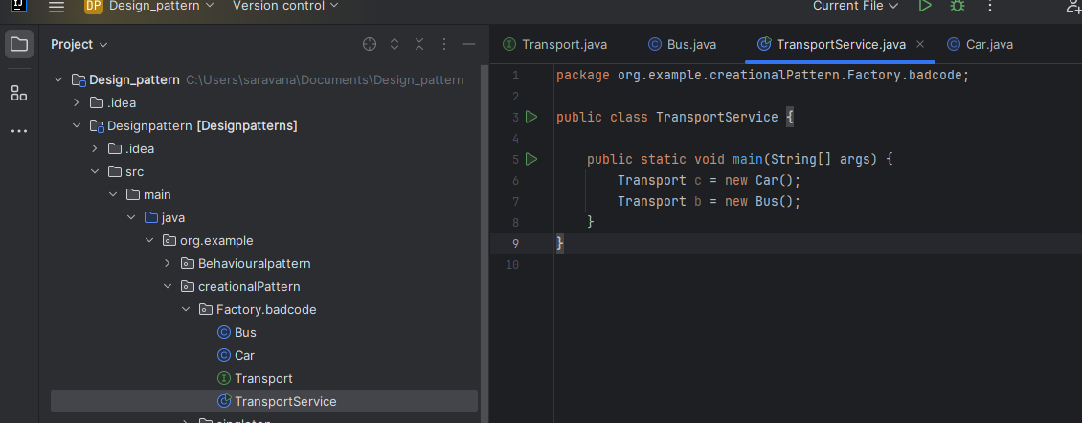

Good code
entha class than nabaluku object create panuthu
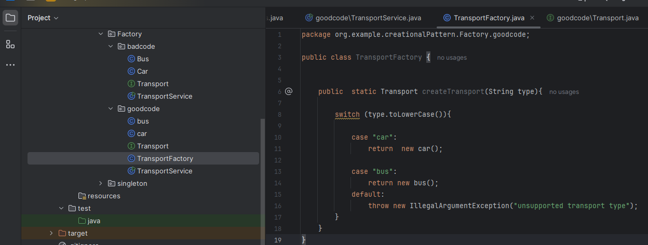

Eppid than call panurom client thirumba thirumba object create pana theva illa
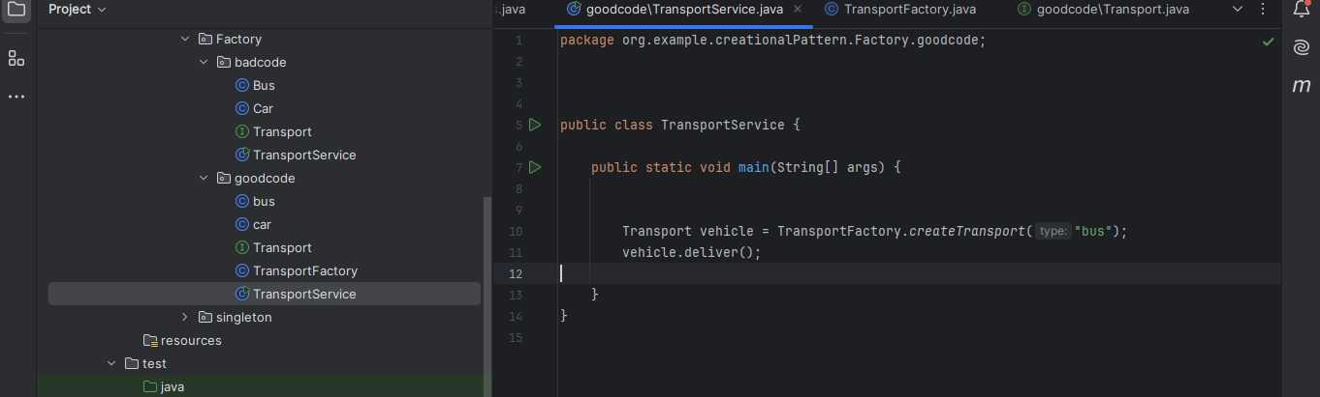

Bulder pattern
badcode

house class
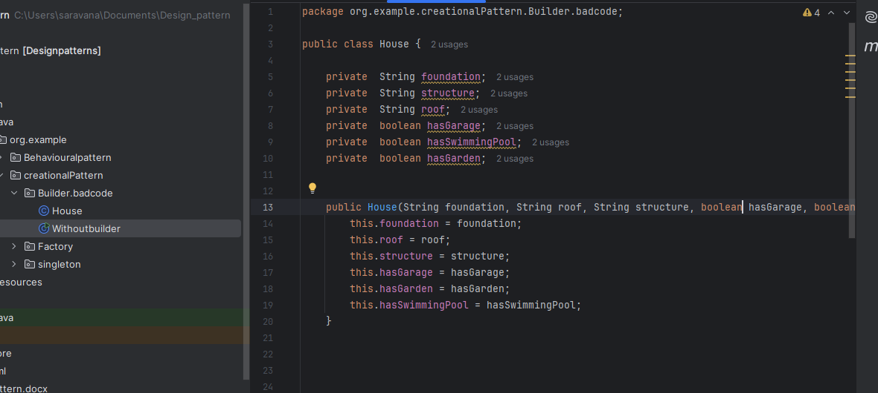

Enga pathana neraya value constructor la set panirupan
edhula oru 3 values matum than mandatory value mathathu lam optional
Edhu thaniya 3 constructor eruka mathiri set pannaum illana 3 values and balance kulam default constructor nu value erukura mathiri set pnanum. Eppidi 2 constructor set pannaum.
Constructor la correct ha value tharanum.
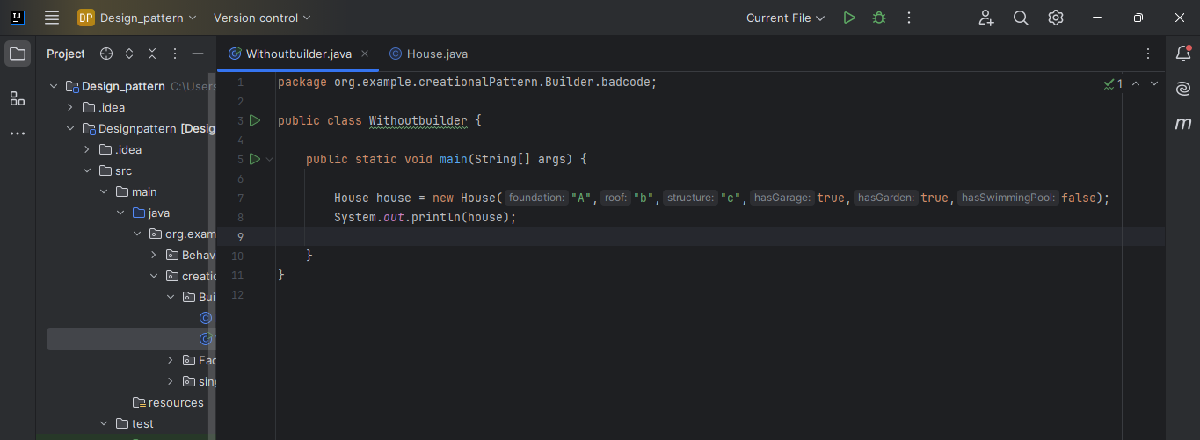

Goodcode
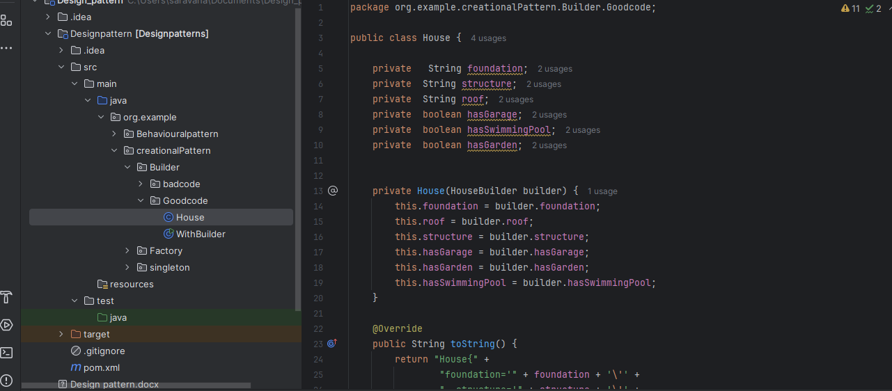
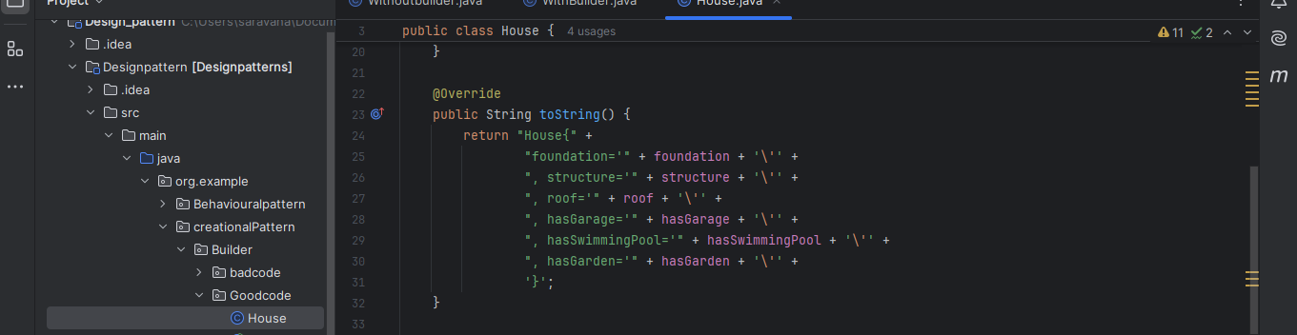

Using house builder class to set the instance varaiable of house and create object of house
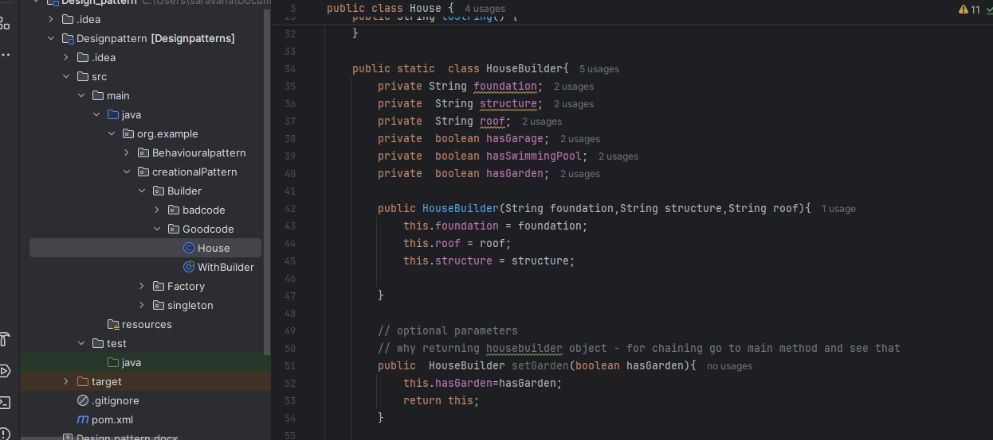

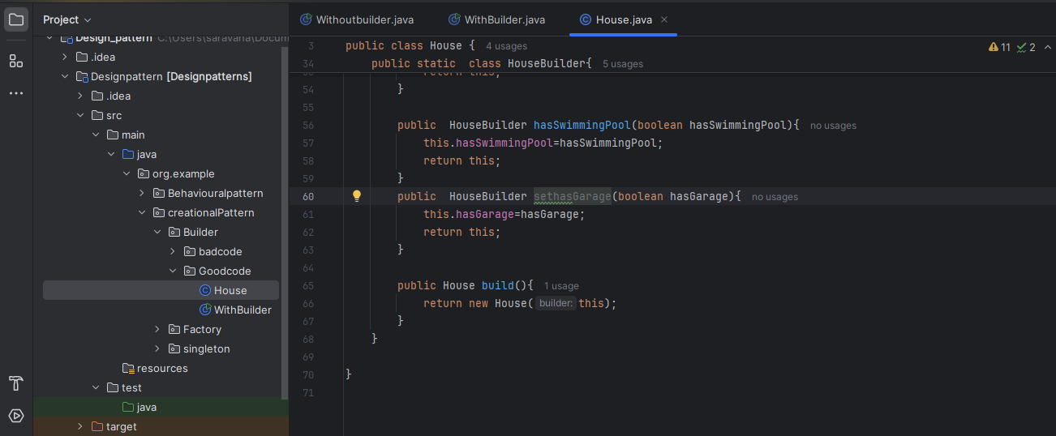

Give all values

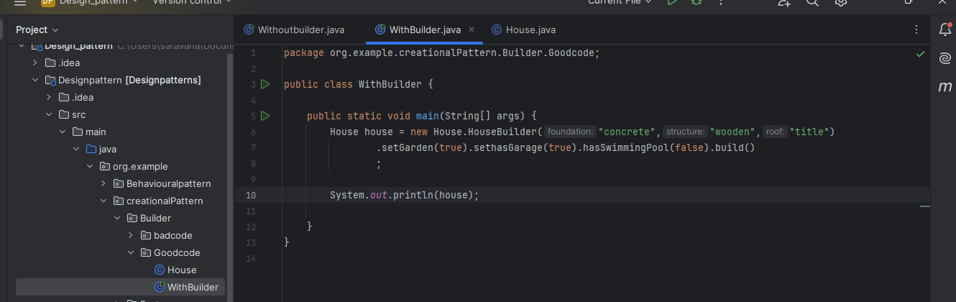

Gives somes input other value java takes default value
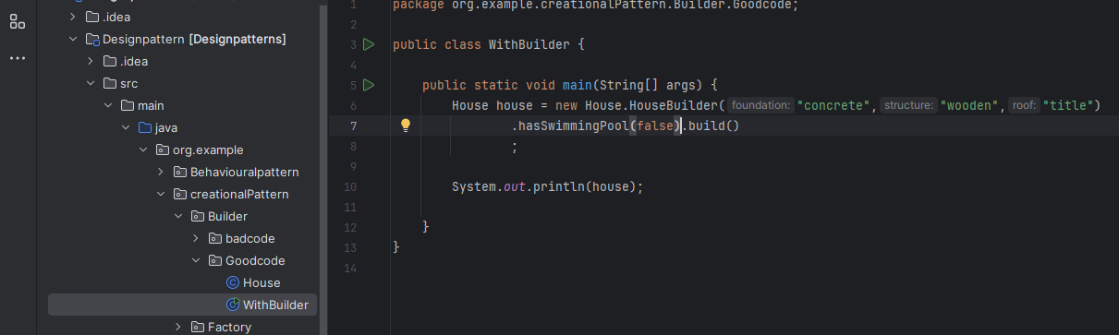

Prototype pattern
use case –to save the current state of the game.
It uses deep copy concepts

Badcode
creating one gameboard and the pieces
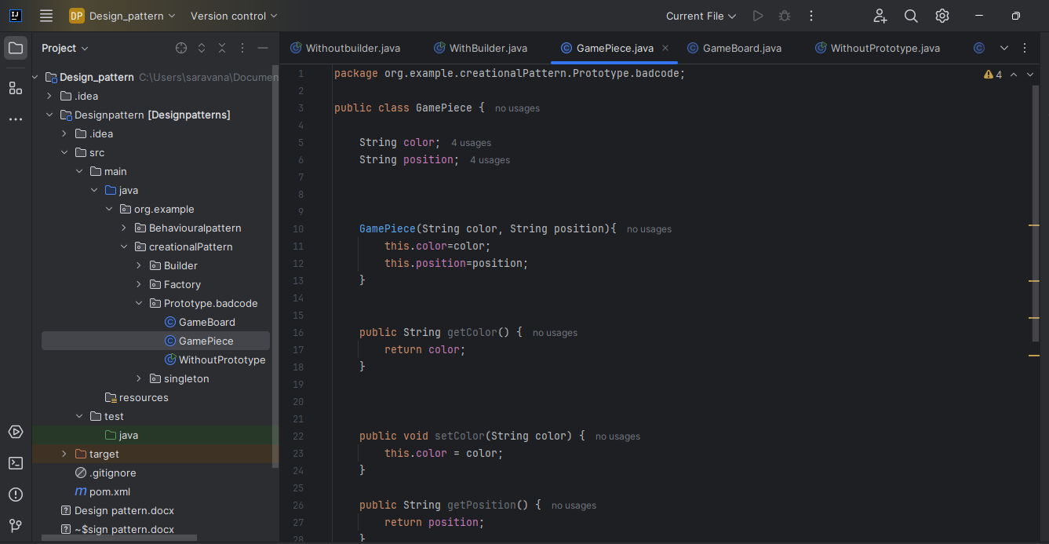

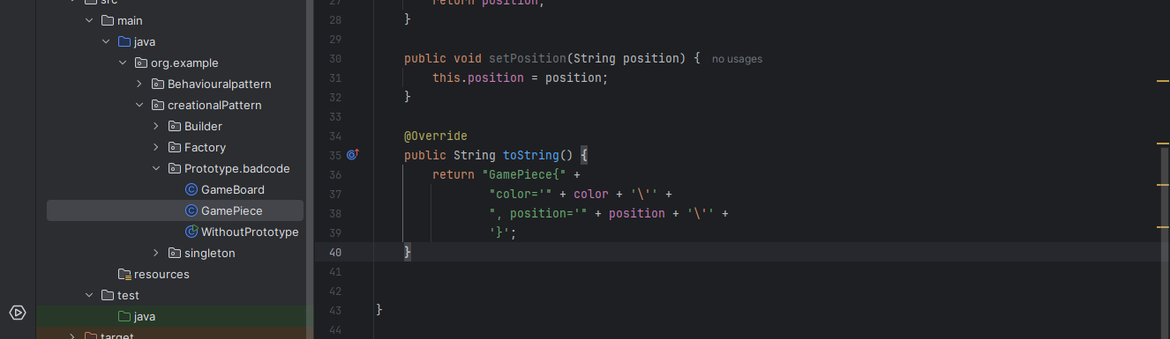

GameBoard
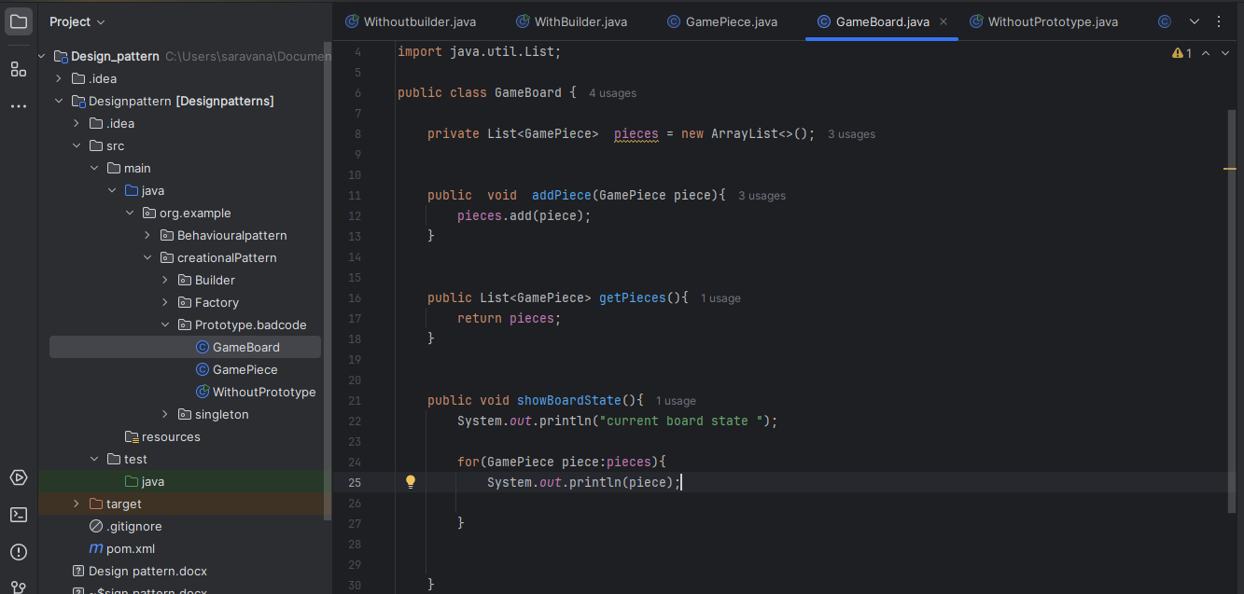
Here if I change anything in game piece I need to change in client code also
tightly coupled

Client responsibility is only to call not to create object
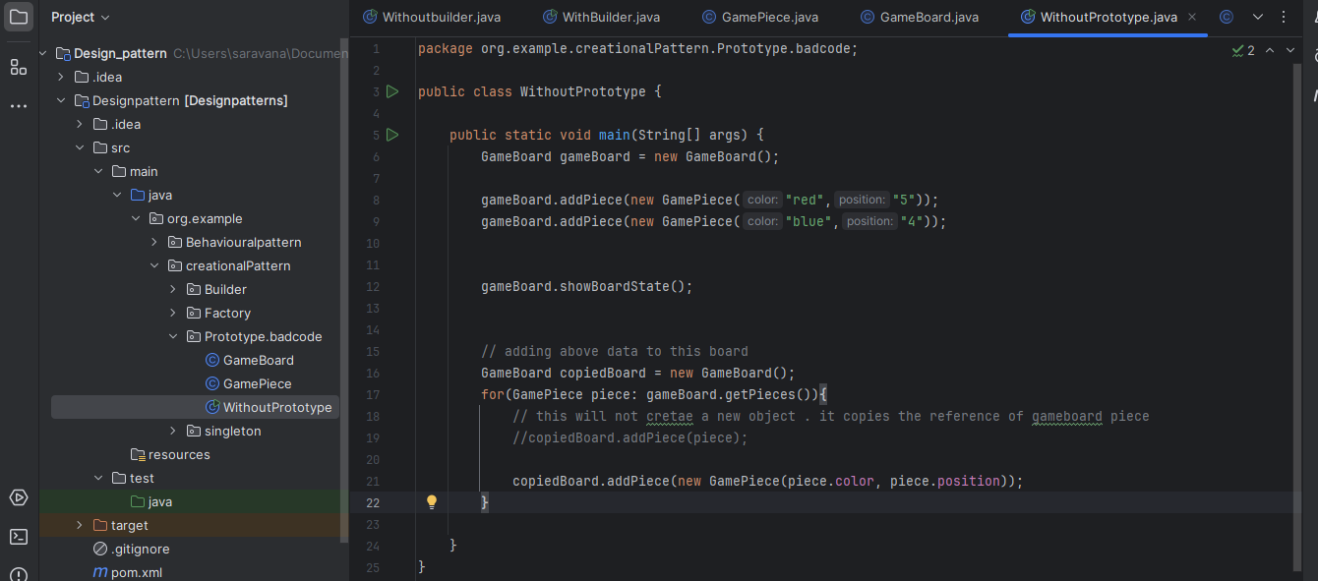

Why we need interface in prototype direct ha va class laya antha method eluthikalam la
interface
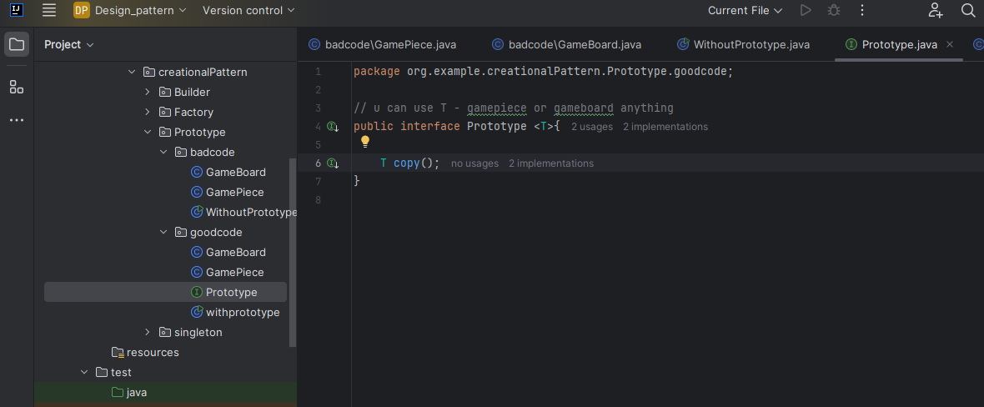

Gamepiece
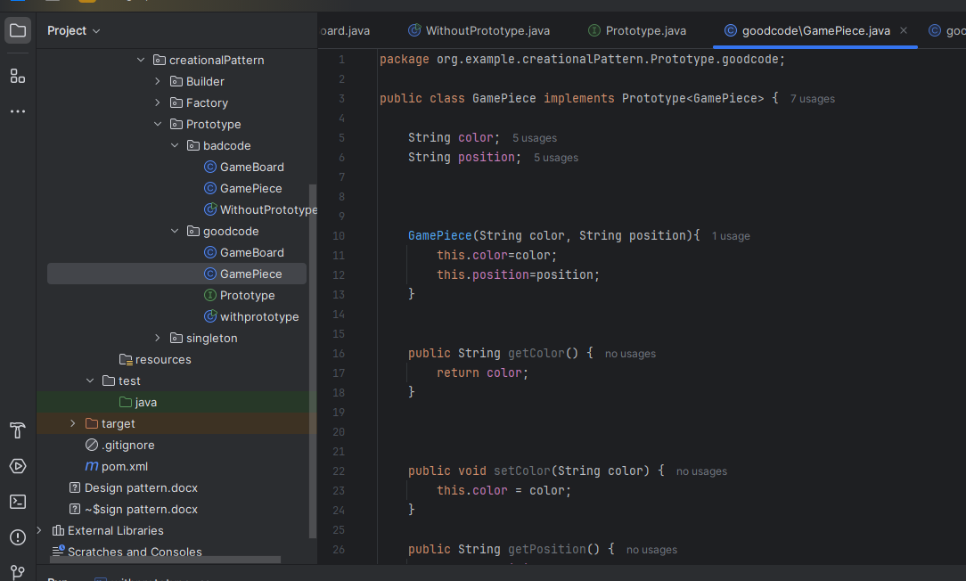

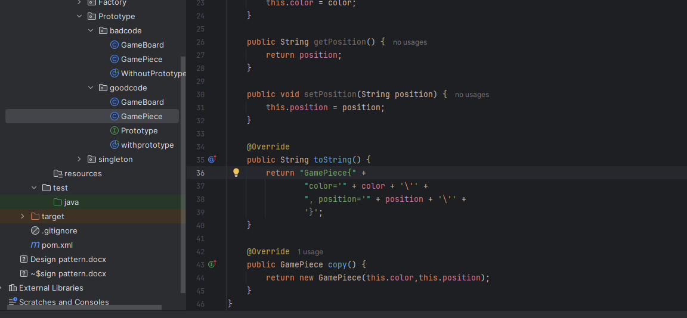

Gameboard
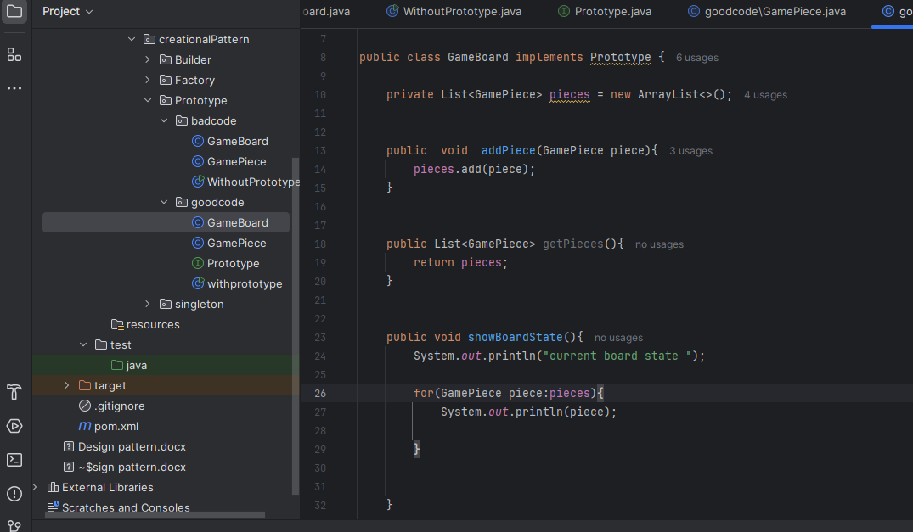

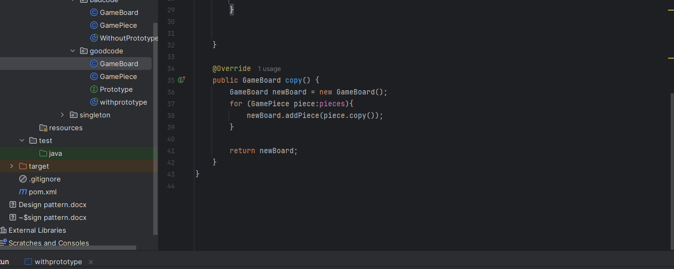

Main class
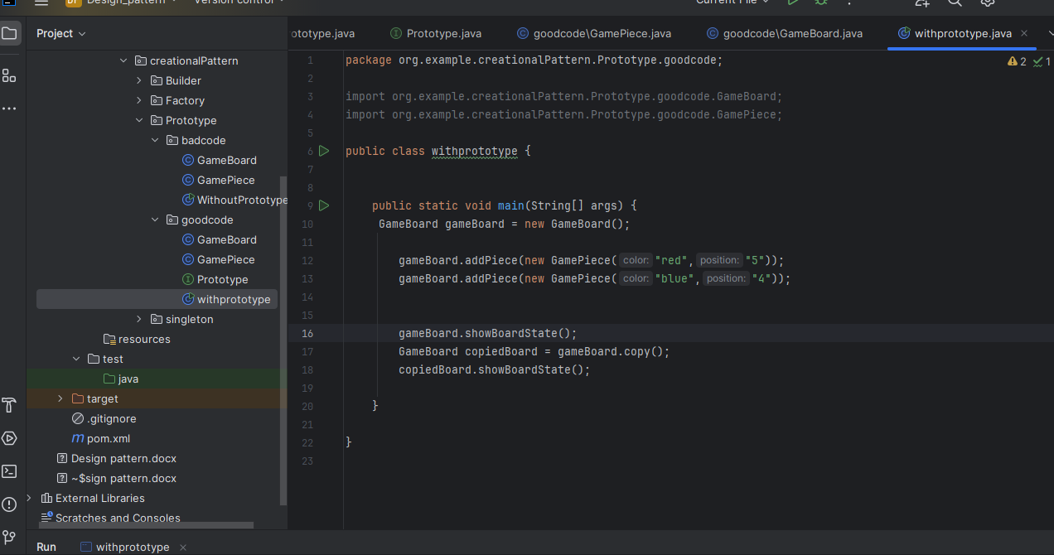

Structural design pattern
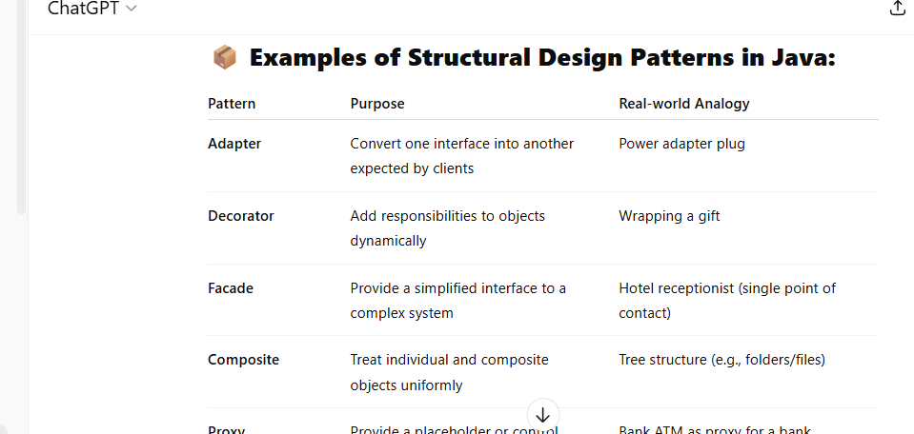
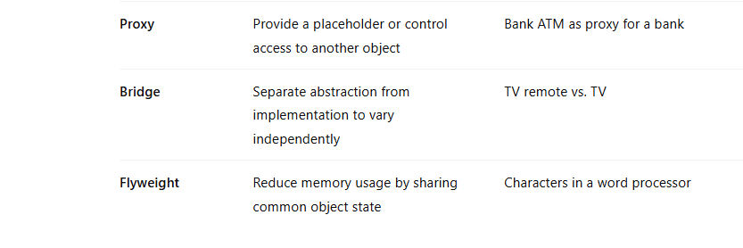
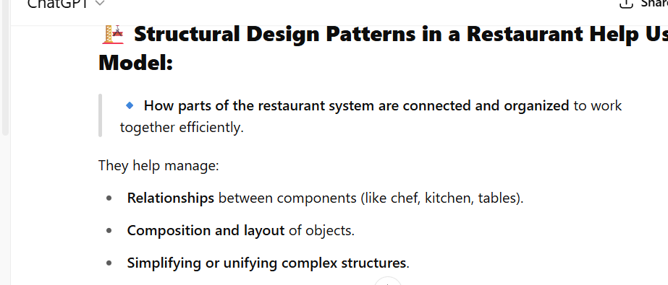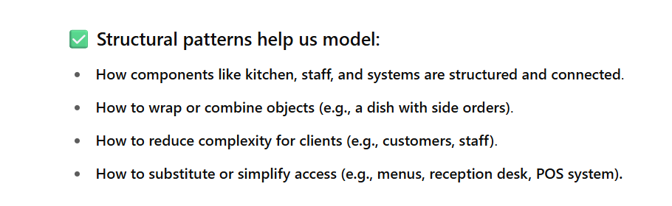
Adapter design pattern
badCode
Create one interface
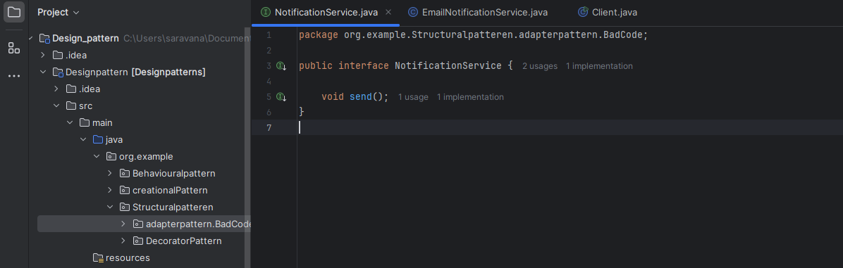
created one concrete class
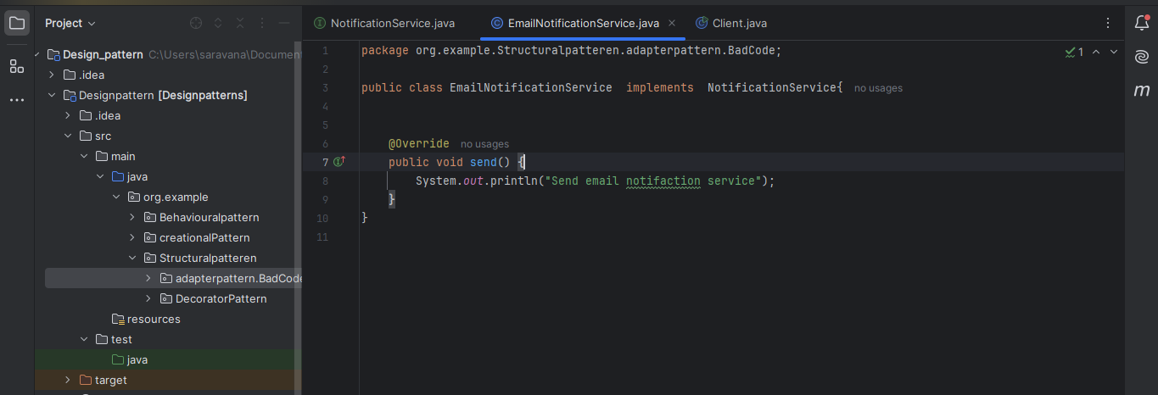
Client code
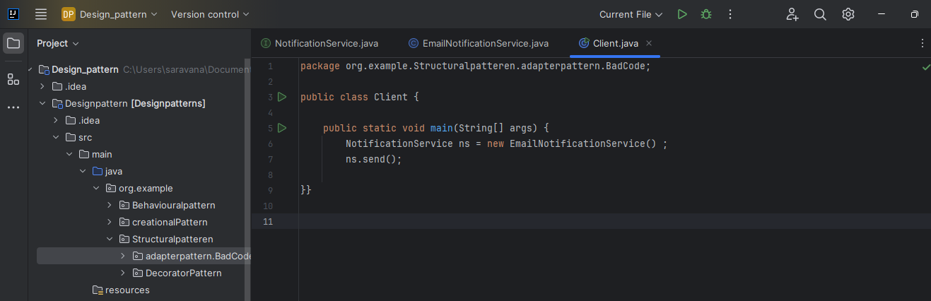

Issue
emailnotification getting older
now I want to change the emailnotification service to sendgrid service without changing the client code .

Good code
Create adapterclass implements the notification service interface and instance variable as sendgrid
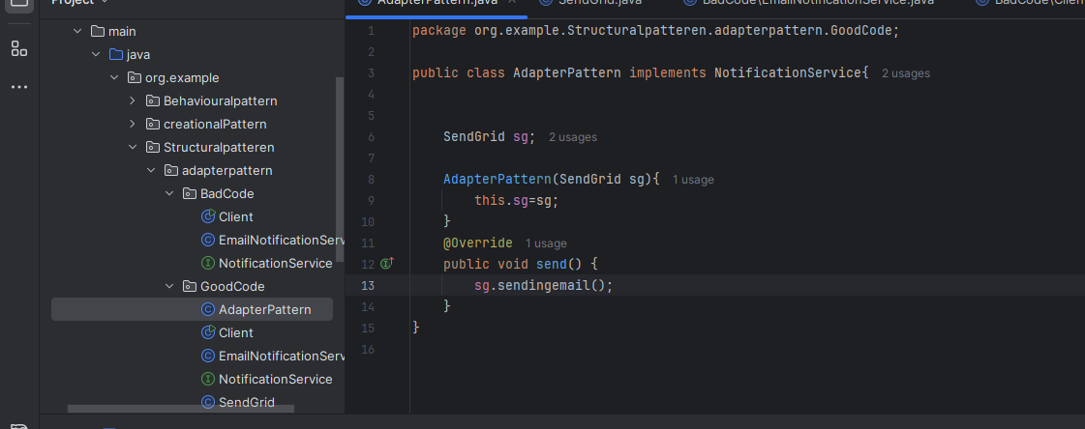

Clientcode
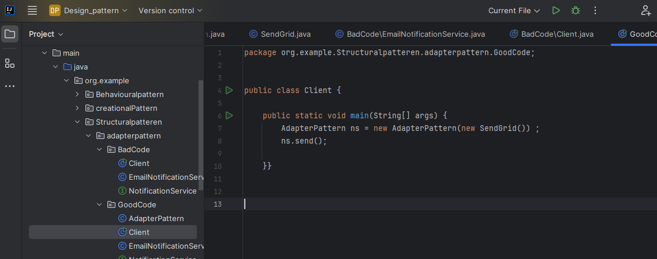

Decorator Pattern
herw we implements interface pizza in abstract class PizzaDecorator. There is no rule to implement all method in interface or partiall method. Its depend on us if you want you can implement if you don’t want no need to implement
purpose of abstract class implements interface is
consider you are creating a restaurant , your restaurant name is abc and it has many branches. You will follow some things basic right prepare food, billing, put this two things in interface
billing is common for all branches put that in abstract , prepare food is common for specific branches you can implement in specific sub classes. Or if you implement both the method in abstract class . no need to implement the method in subclasses unless you want

Bad code
Conside we have basepizza class we want cheespizza class we extend the base pizza
if we want mushroompizza we extend base pizza .if we want cheesemushroom class we extend the cheespizza class like that we are extending. This leads to subclassexplosion. It will leads to
2 to the pwer n
GoodCode
here N
creating a object and passing it to all decorator class not need to create a subclass
create a base class and main class like cheese,mushroom

create pizza interface
I use this interface in two class one is basePizza and another is pizzadecorator abstract class
In general we frst create base pizza and then add topings
I create a basepizza object and then pass the pizza object in the decorator class
passing base pizza in cheese decorator class
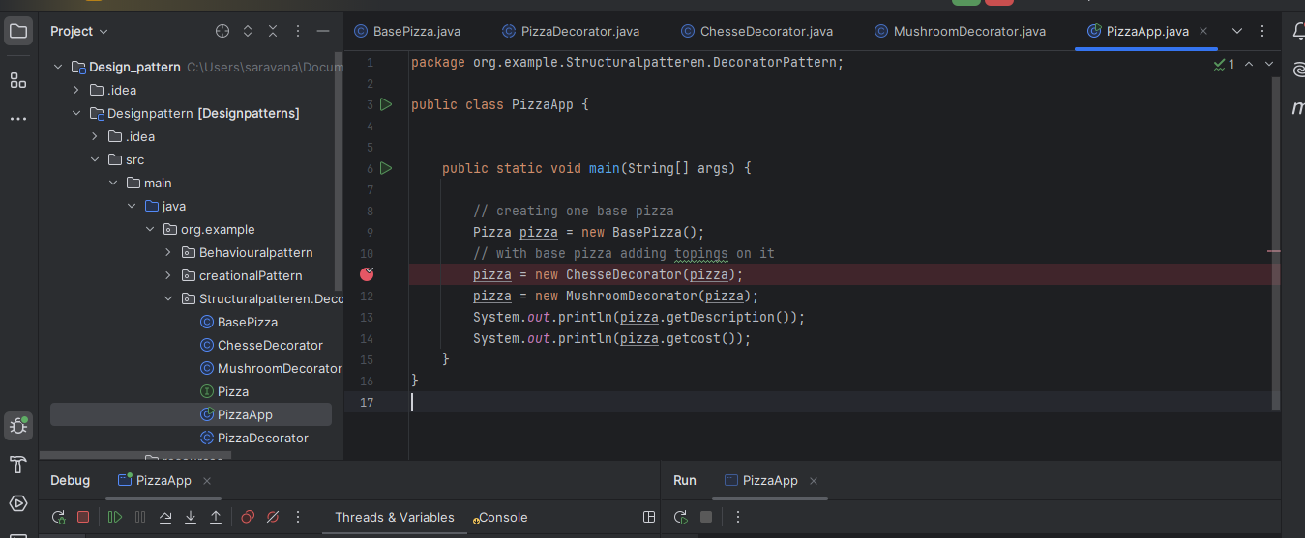
Seeting the pizza in pizza decorator class using super keyword
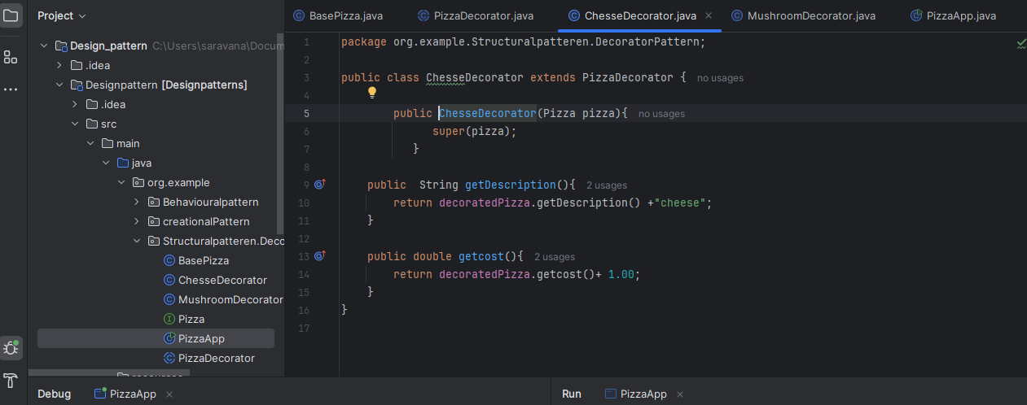

Pizza has been setted in decoratedpizza variable
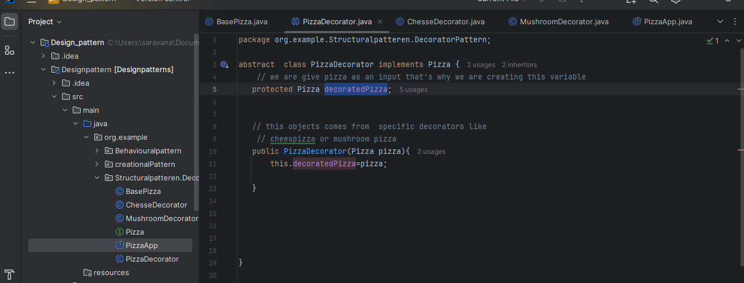

We are calling cheesepizza getdescripition method inside it call normal pizza description and add necessary cheese and values
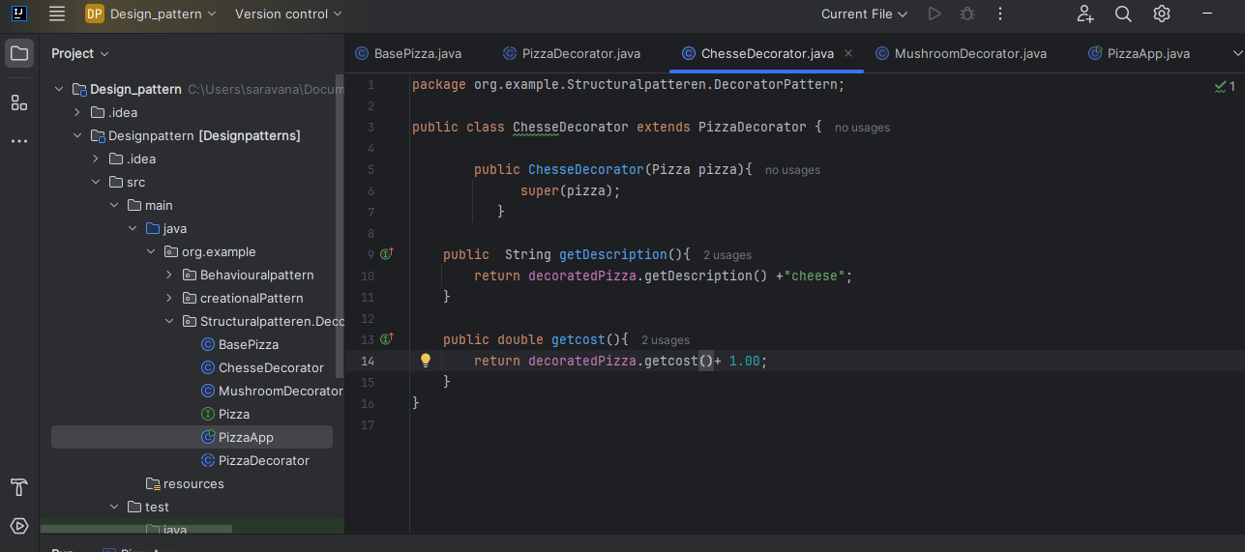

Composite pattern
Used to maintain hirerachy.
here I structured like folder contains files
our use case is folder contains files and subfolder.
subfolder contains lot of files.
bad code
File.java class
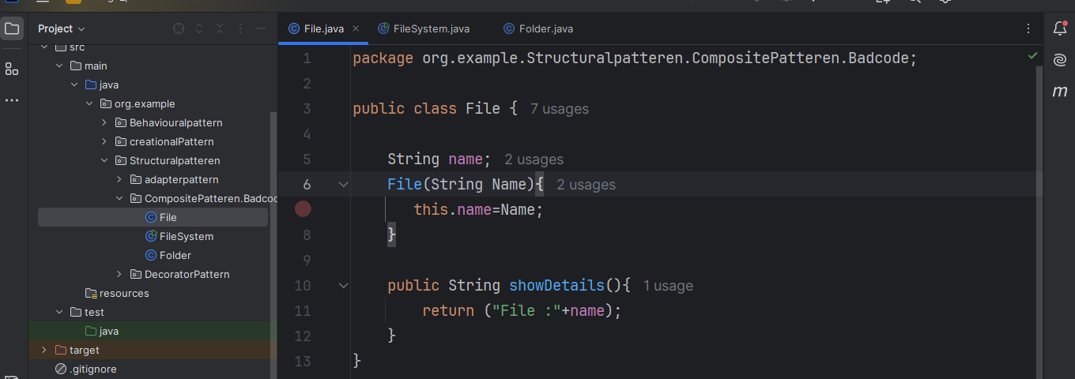

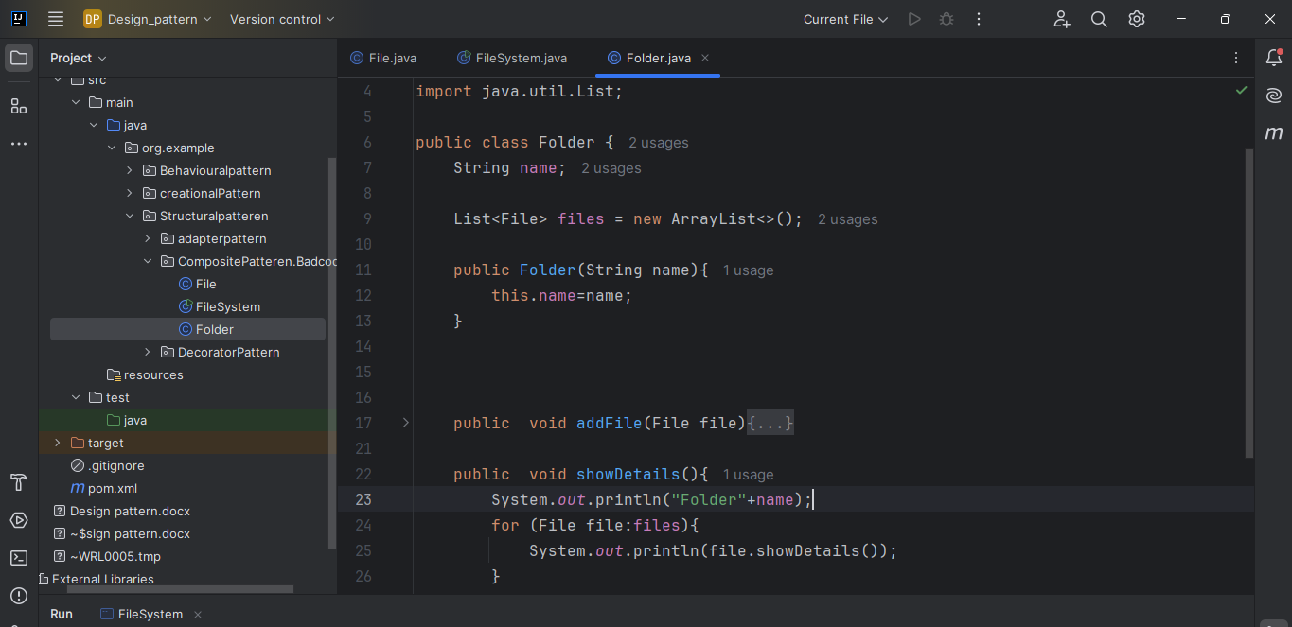

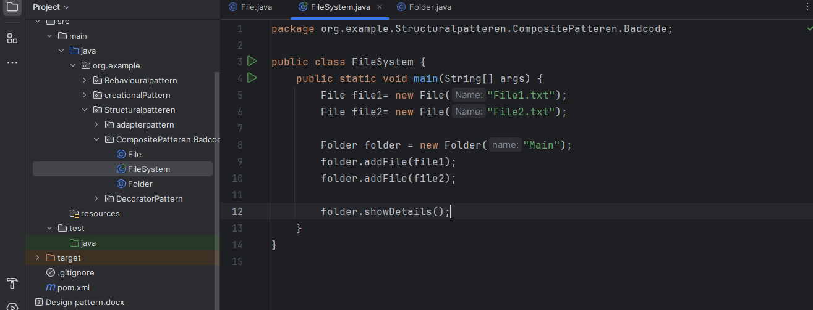

Goodcode.
just implementing one interface
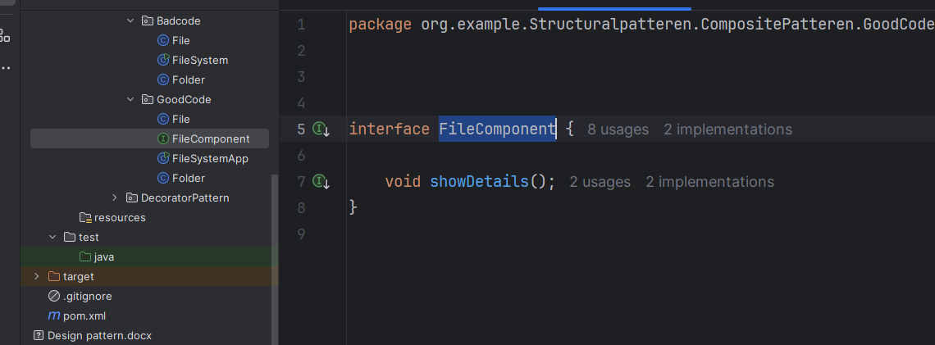
implemented in both the class
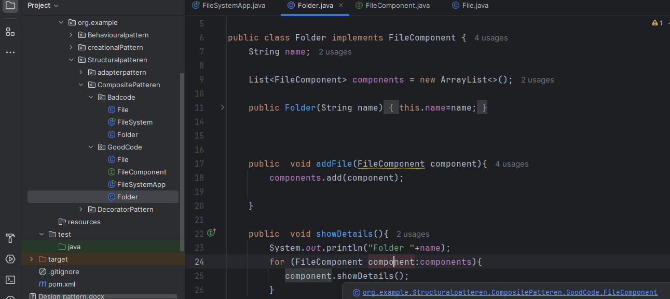

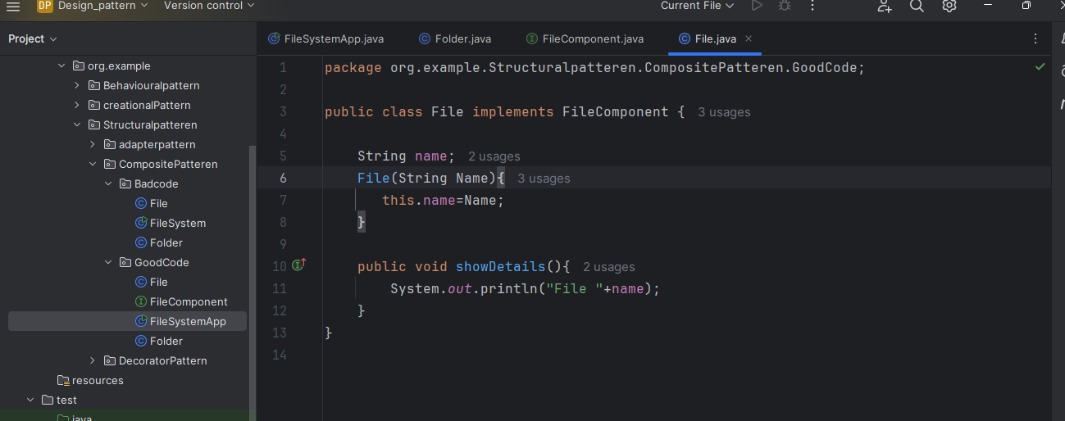

Client code
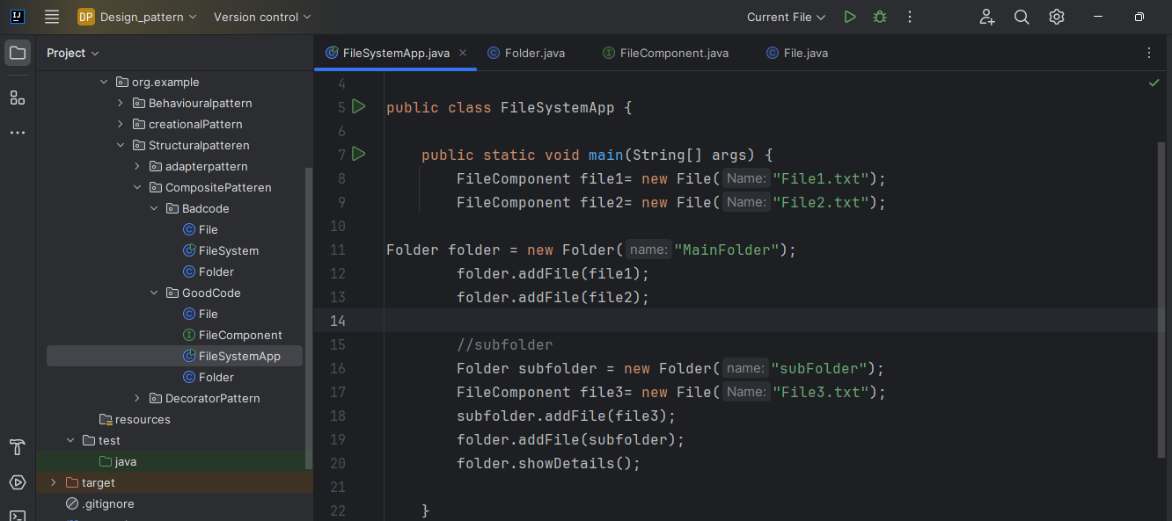

Façade pattern
façade means large wall in front of the building
use : api gate way
bad code
create 3 classes consider the 3 class as microservices
client code directly calls the method .
we are exposing the methods to client
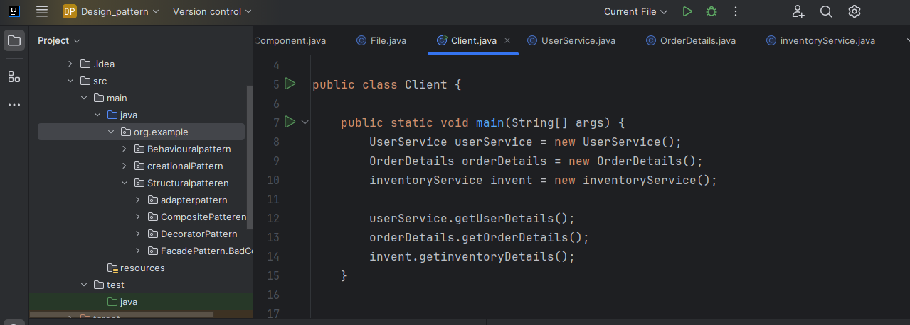

Goodcode
just implementing one class
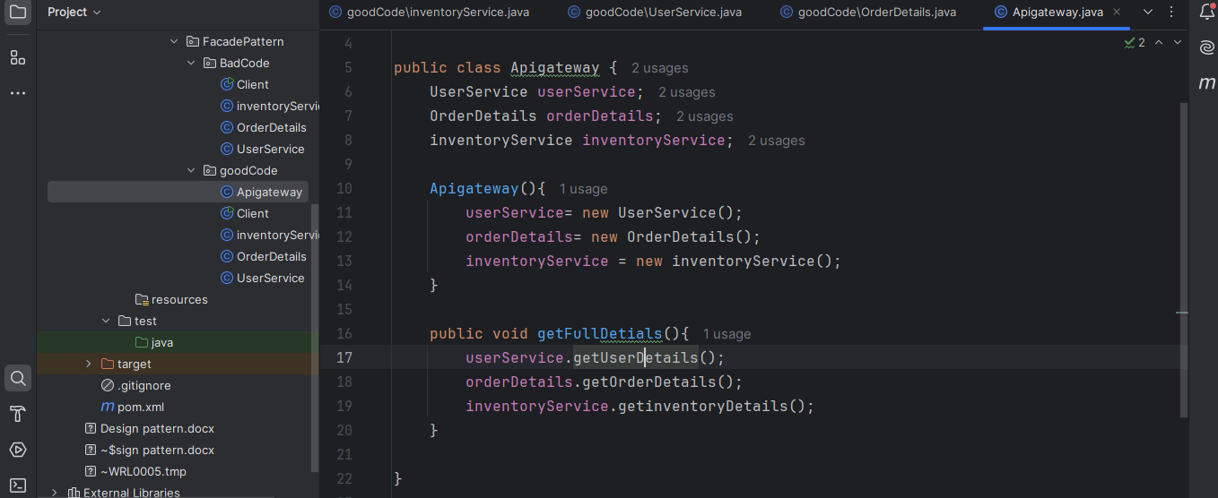

Client call that class along to get the all details
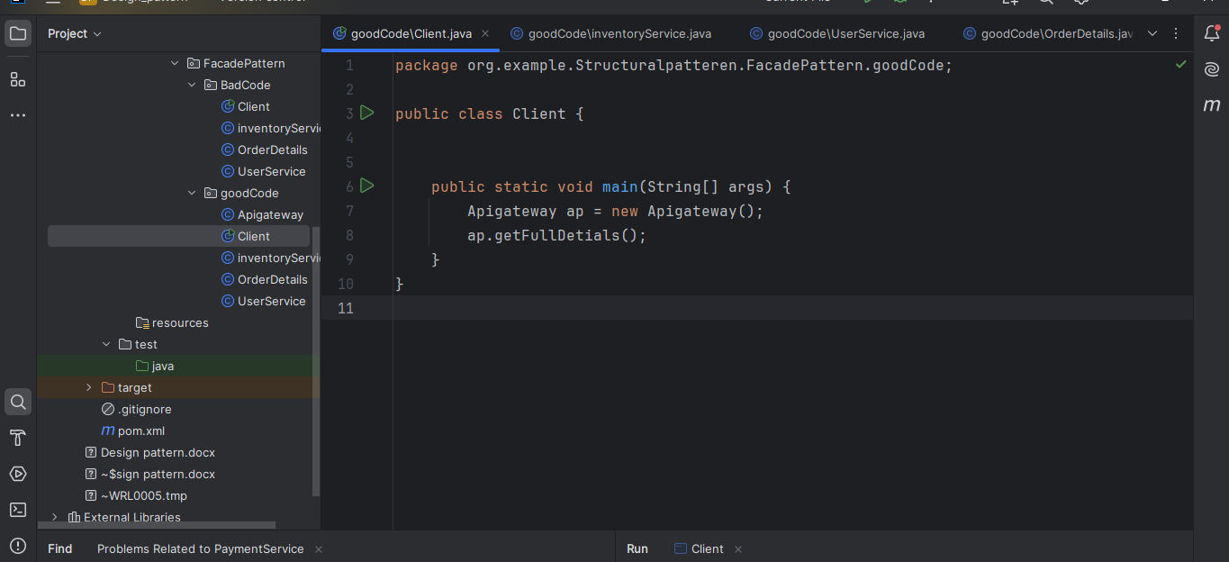

Proxy pattern
Your have source data . you just create a copy of the source data and shows necessary data.
bad code
creating interface
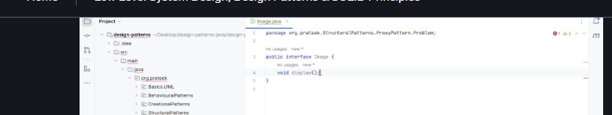
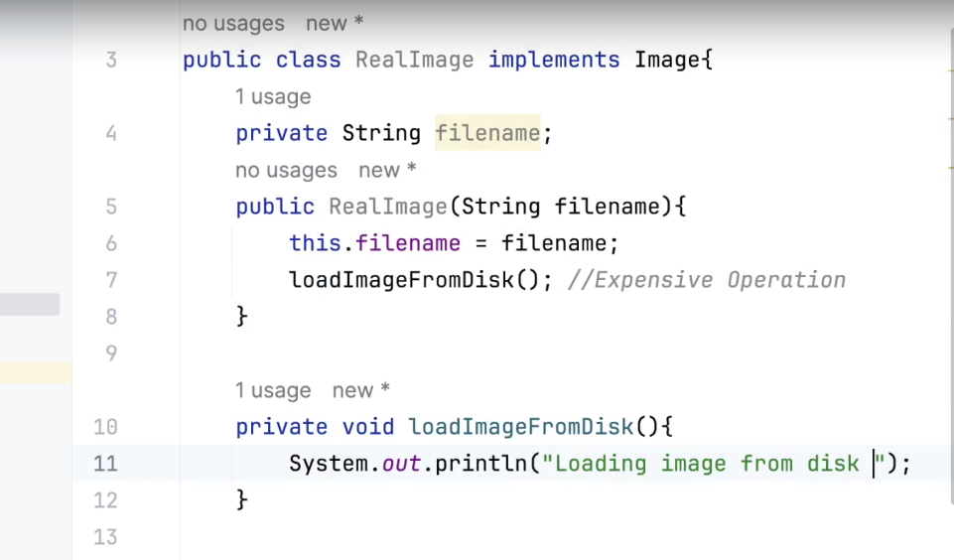
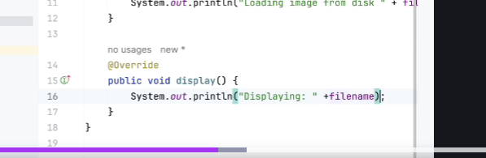

Mediator pattern
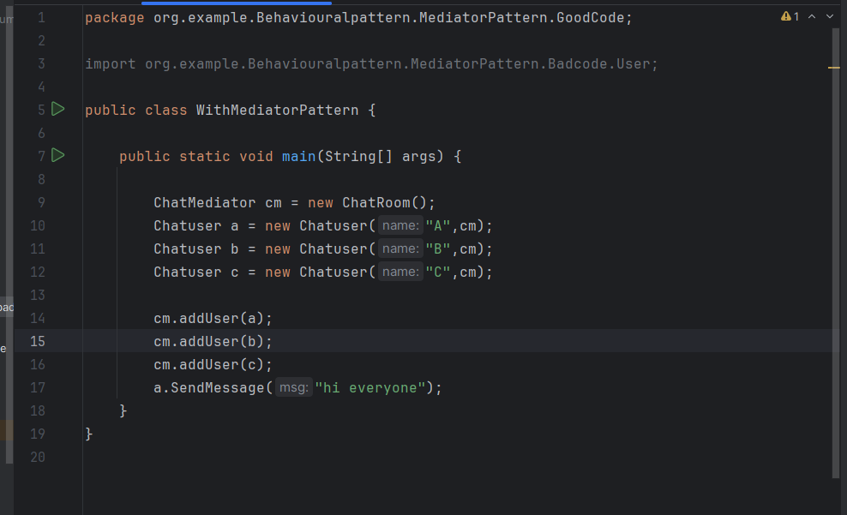
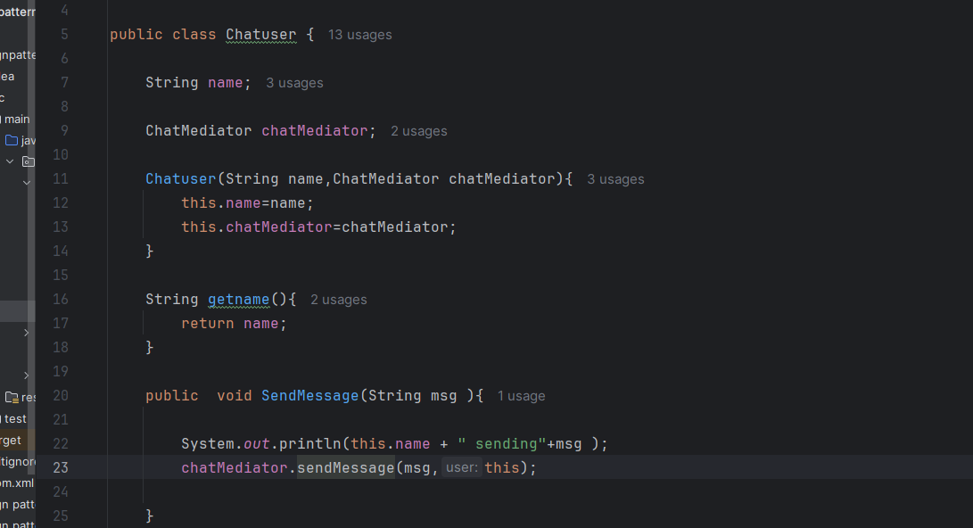
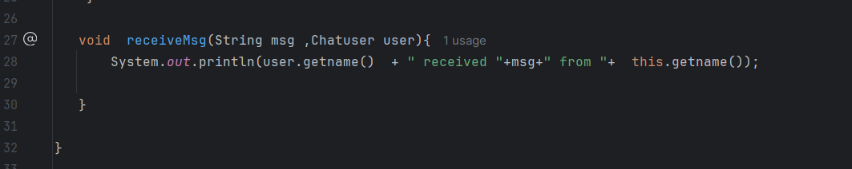
ChatMediator
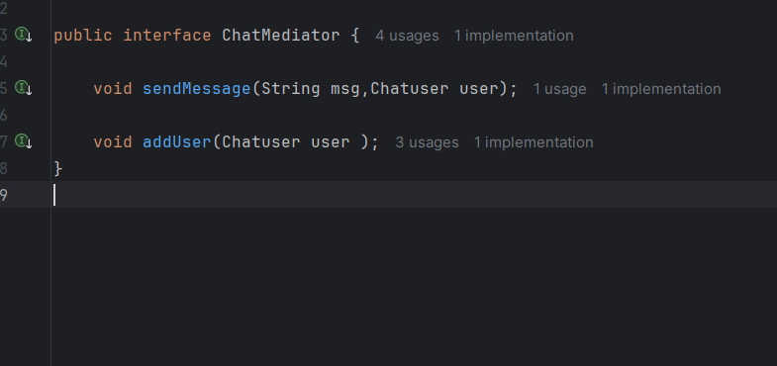

Chatroom
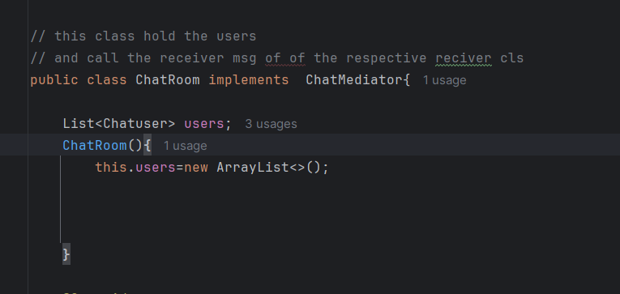
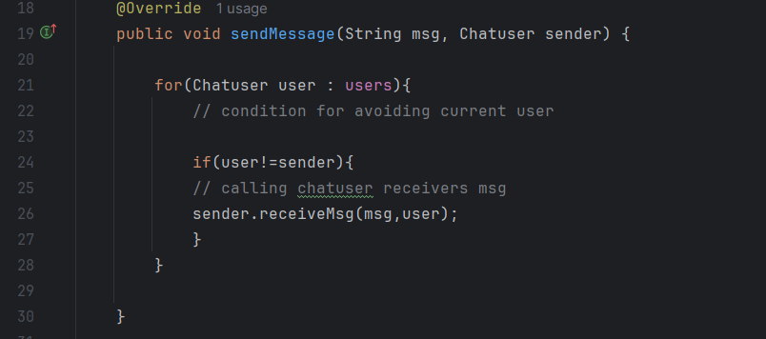
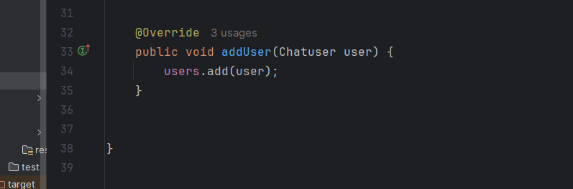
Left over
structural - flyweight Pattern ,proxy pattern
creational – abstract factory pattern
behavioural – state pattern,commando pattern
Easy to study
Momento pattern
obsever pattern
Startegy pattern
template pattern
Mediator
singleton
Factory
façade pattern
adapterpattern

